Lab Guide: Getting Started with Generative AI in watsonx.ai

Author: Elena Lowery, elowery@us.ibm.com;
Ryan Kather, ryan.kather@ibm.com
Contents
Overview 3
Required software, access, and files 3
Generative AI and Large Language Models 4
Part 1: Understand LLM capabilities 6
Part 2: Integrate LLMs with applications 31
Conclusion 40

Overview
In this lab you will learn how to implement generative AI use cases in watsonx.ai. Watsonx.ai is an AI platform which can be used to implement both traditional machine learning use cases and use cases that utilize Large Language Models (LLMs).
We will take a closer look at the following use cases:
- Generation
- Summarization
- Classification
Note: LLMs are a type of a foundation model. In IBM tools and documentation, the terms LLM and foundation models are used interchangeably.

Required software, access, and files
- To complete this lab, you will need access to watsonx.ai in IBM Cloud.
- A Python IDE with Python 3.10 environment (Visual Studio Code or PyCharm)
- You will also need to download sample prompts and code samples from this folder.
- Unzip the downloaded folder if it was zipped up during download. In the lab we will refer to this folder as /Lab_Files.

Important note: Some screenshots in the lab may be slightly different from the product. If you have questions, please ask your workshop instructor.

Generative AI and Large Language Models

Generative AI is a new domain in AI which allows users to interact with models using natural language. When working with Large Language Models (LLMs), a user sends requests (prompts) to a model, and the model generates a response. To an end user generative AI may look like a chatbot or a search engine, but implementation of generative AI is different from legacy chatbots that rely on hardcoded business rules and search engines that use indexing.

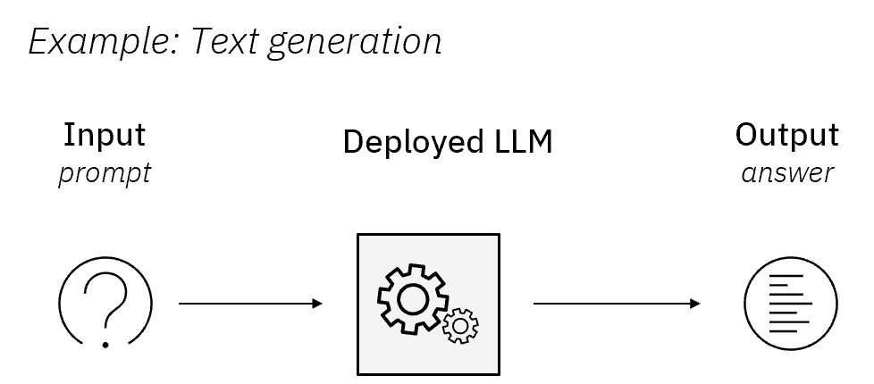

Figure 1: Prompt Lab in watsonx.ai

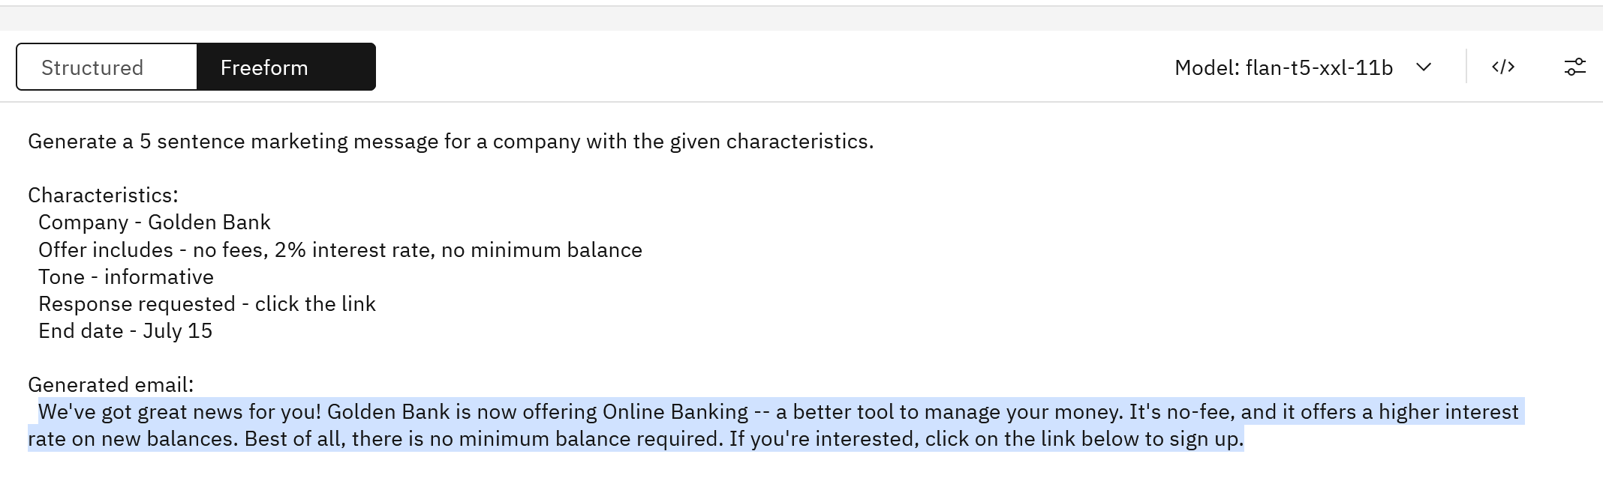
Output
Prompt

Unlike traditional machine learning models, which always require training, LLMs are pretrained on a very large dataset. There are dozens of LLMs, which are developed by different companies. Some companies contribute their models to open source, and many of them are available on the LLM community site Hugging Face. It’s up to the LLM developer to publish information about the model and the dataset that the model has been trained on. For example, see the model card for one of the popular open source models, Mixtral-8x7B-Instruct-v0.1. In general, all LLMs are trained on publicly available data. IBM is one of the few companies that publishes detailed information about the data that was used to train the model. This information can be found in documentation and Research Papers published by IBM.

You can think of the data that the model has been trained on as its “knowledge”. For example, if the model was not trained on a dataset that contained 2022 Soccer World Cup results, it will not be able to generate valid/correct answers related to this event. Of course, this applies to all business use cases in which we need models to interact with proprietary enterprise data. We will explain how to solve this problem later in the lab.

Two more factors influence LLM capabilities: size and instruction-tuning. Larger models have been trained on more data and have more parameters. In the context of LLMs, the number of parameters refers to the number of adjustable weights in the neural network that the model uses to generate responses. Parameters are the internal variables of the model that are learned during the training process and represent the knowledge the model has acquired.

While it may seem obvious that a larger model will produce better results, in a production implementation we may need to consider smaller models that meet our use case requirements because of the hosting and inferencing cost.

Instruction-tuned models are models that have been specifically trained for tasks such as classification or summarization. See IBM documentation for other considerations when choosing a model.

As we work through the lab, we will introduce a few more important LLM concepts.

Part 1: Understand LLM capabilities

In this lab, we will use the Prompt Lab in watsonx.ai to interact with LLMs included in the platform.

Typically, users (prompt engineers or data scientists) have three goals in this phase of the LLM lifecycle:

  - Find if LLMs can be used for the proposed use case
  - Identify the best model and parameters
  - Create prompts for the use case.

- If not already in the environment, Log in to your IBM Cloud account. Your lab instructor will provide the URL and userid/password.

- If you are not already in watsonx.ai service, you can navigate to it from the IBM Cloud Resources page.

  - Search for Watson Studio in the search box on top of the page.



- On the Watson Studio service page, make sure to select Launch in IBM watsonx.

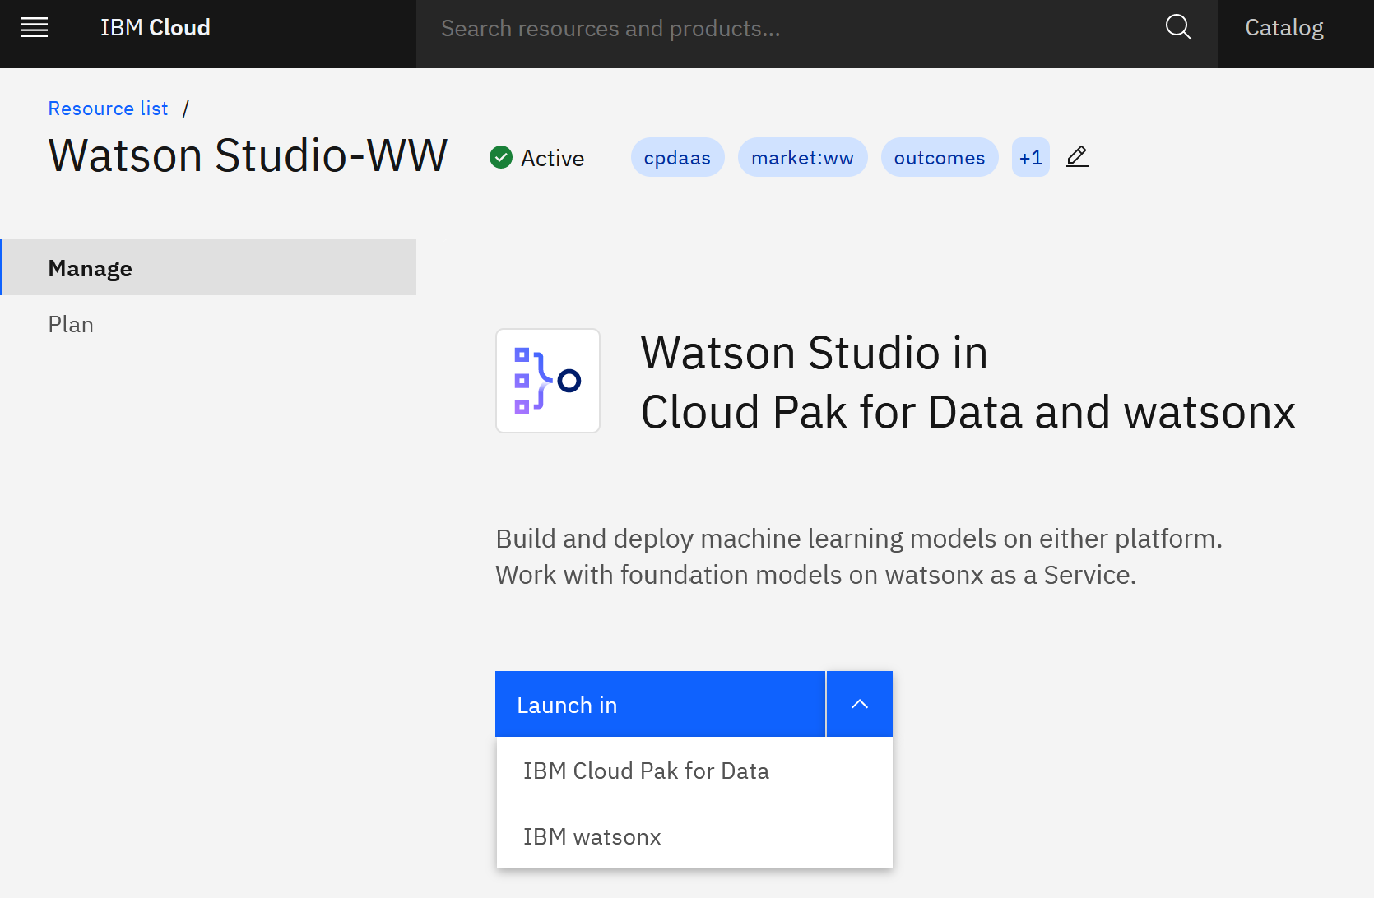

- From the main menu in the top left corner select Projects -> View All Projects.

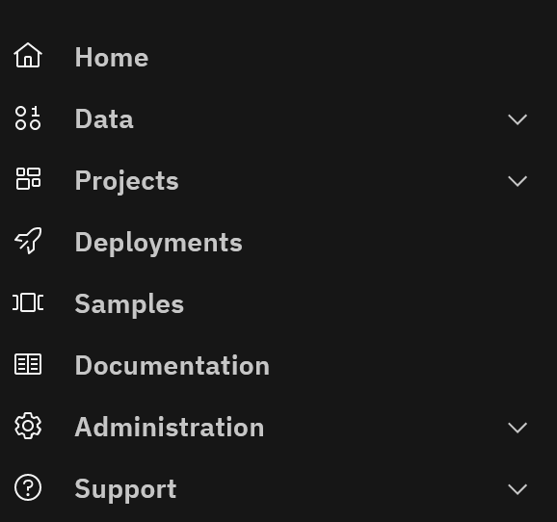

- Click on the New Project button. Select Empty Project and add your initials to the project name. For example, LLM-workshop-YI.

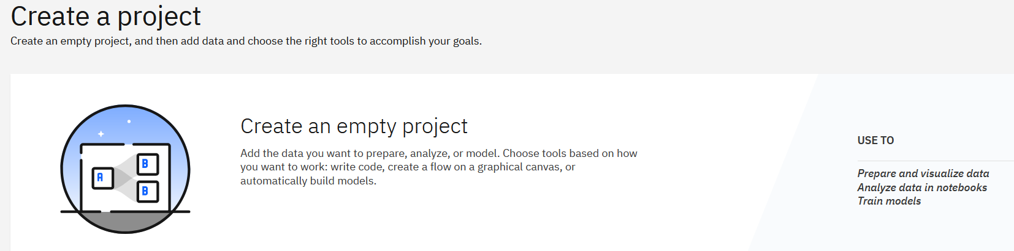

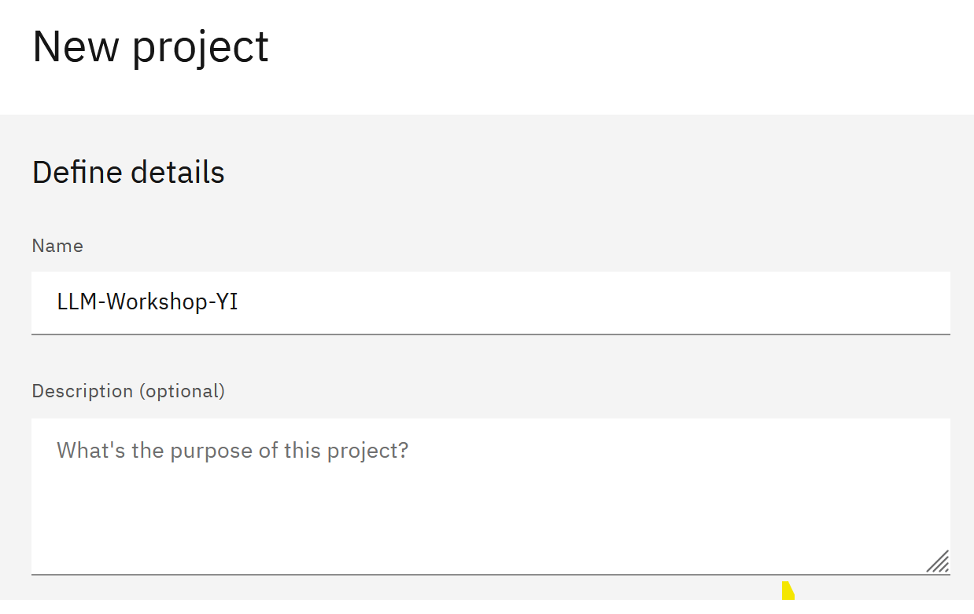

- Switch to the Services and Integrations tab, then click Associate Service.

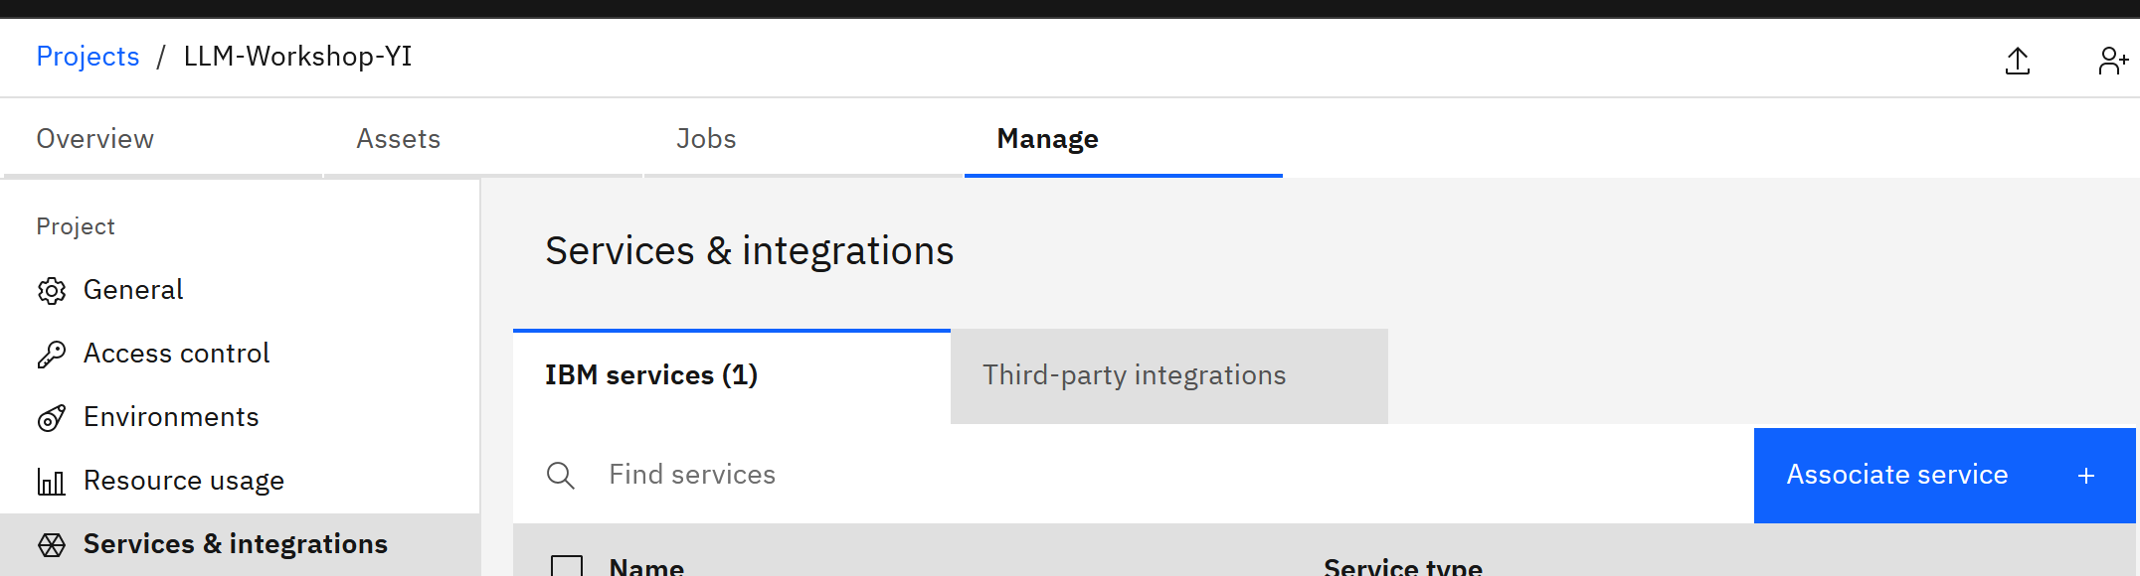

- Select the displayed Machine Learning service and click Associate.

Note: if the service is already associated, click Cancel and proceed to the next step.

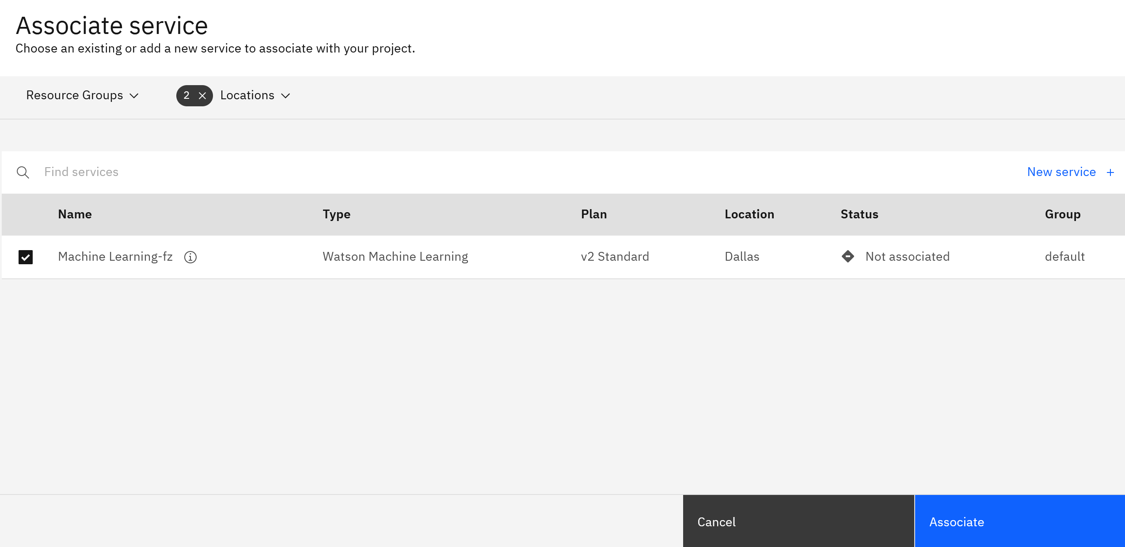

- Switch to the Assets tab, then click the New asset button.

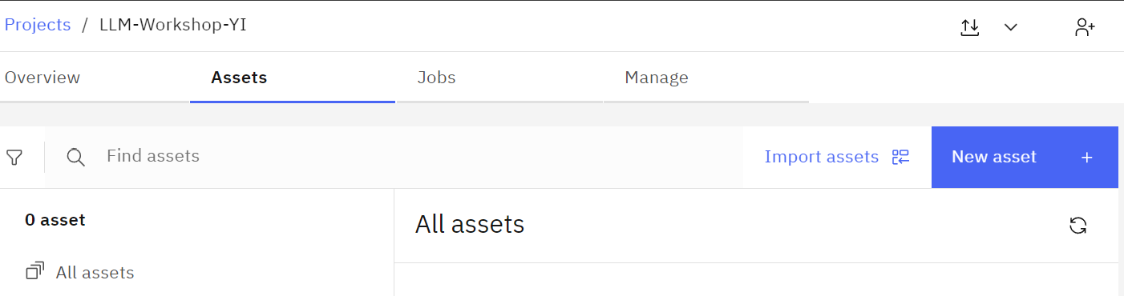

- Click on the Experiment with foundation models… tile.

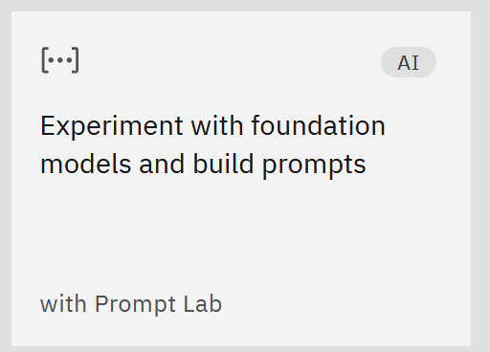

Before we start experimenting with prompting, let’s review some key concepts about model selection.

As you try different models, you will notice that some models return better results with zero-shot prompting (providing instructions without examples) than others. Usually, models that have gone through fine-tuning, instruction-tuning, and RLHF generate significantly better output.

- Fine-tuning means that the original LLM was trained on high-quality labeled data for specific use cases. For example, if our goal for the model was to “Act as an IT architect” when generating output, during the fine-tuning process we provided labeled data examples of a writing style for IT architecture.
- If the model goes through the instruction-tuning process, then it will be able to generate output without explicit instructions, such as “Can you answer this question?” The model will understand that you are asking a question from the context and sentence structure.
- RLHF (Reinforcement Learning from Human Feedback) is a technique that is used to improve model output based on feedback provided by testers, usually domain experts (for example, lawyers for tasks related to generation of legal documents). Before the model is released, it is updated based on testing results.
While all vendors can say that their model has been fine-tuned, instruction-tuned, and has gone through RLHF, the industry benchmarks for LLMs are not mature. Even benchmarks that may eventually become the industry standard (for example, TruthfulQA) test only certain aspects of model output.

A potential solution to this issue is the research done by the broader LLM community. The LLM community is very active; information about the quality of models usually becomes widely known through various community resources such as articles, blogs, and YouTube videos. This is especially true for open source vs. proprietary models. For example, search for “llama vs. ChatGPT” and review results. You can also review the leaderboard on Hugging Face, keeping in mind that you will need to understand the evaluation criteria used for the leaderboard (see the About page of the leaderboard).

At this time, llama-70b-2-chat model, is one of the best models for zero-shot prompting. While it may seem like an obvious choice to always use llama-70b-2-chat in watsonx.ai, it may not be possible for several reasons:

- Model availability in the data center (due to resources or licensing)
- Inference cost
- Hosting cost (for on-premises or hybrid cloud deployments).
It may be possible to achieve similar results with other models or with smaller versions of llama by using few-shot prompting or fine-tuning, which is why it is important to experiment with multiple models and understand prompt tuning and model tuning techniques.

Note: Instructions in this lab are written for the llama, granite-13b-chat-v2, flan, and mixtral models, which are available in all IBM Cloud data centers where watsonx.ai is hosted as well as in the on-premises version of watsonx.ai. We encourage you to try other models (for example, codellama), if they are available in your workshop environment.

- After the Prompt Lab UI opens, switch to the Freeform tab.

Select the flan-ul2-20b model. We will review model settings later in the lab.

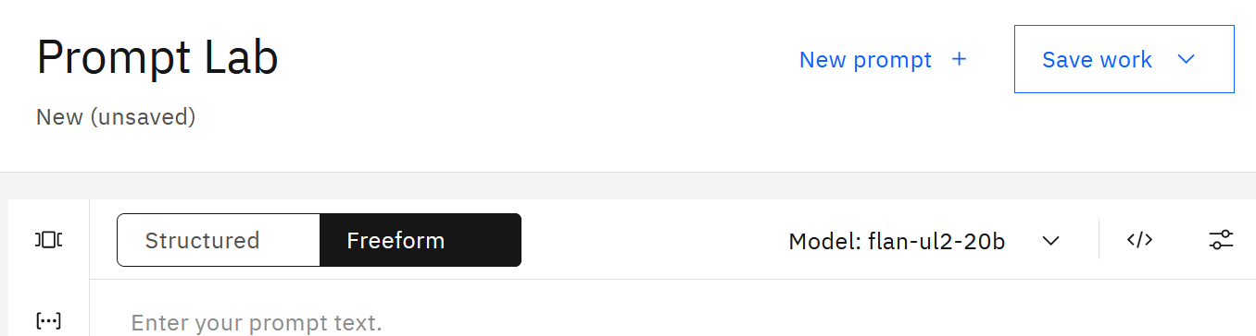

Since most LLMs, including the selected flan model, were trained on publicly available data, we can ask it some general questions.

- Type in the question: “What is the capital of the United States?” and click Generate. The generated answer is highlighted in blue.

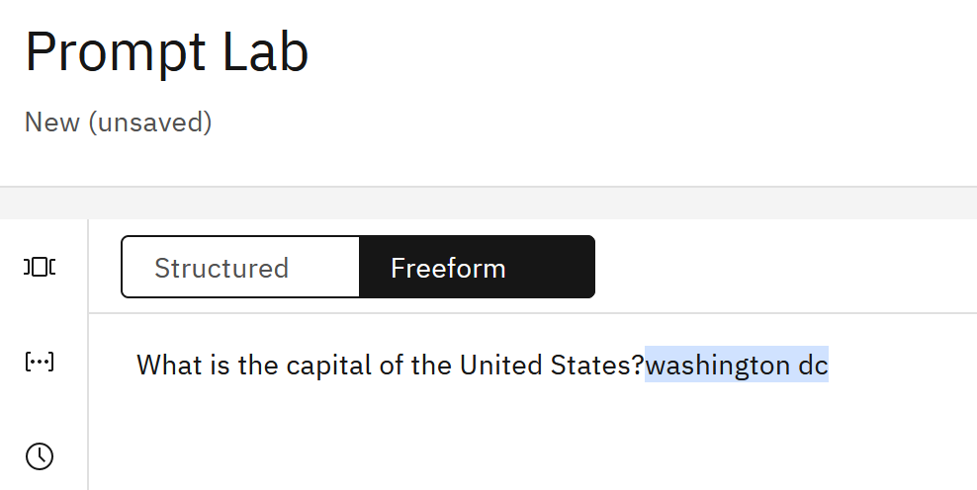

We got the answer to our question without instructing the model to do it because the flan model was instruction-tuned to answer questions. Google, the creator of this model, published the training instructions that were used for the model in this git repository. As you can see in documentation, the instructions are often shown in a “technical format”, but they are still helpful for understanding the best prompting options for this model.

Scroll down to the natural questions section of the git page. Here we can see the various phrases we can use with the model when asking questions.

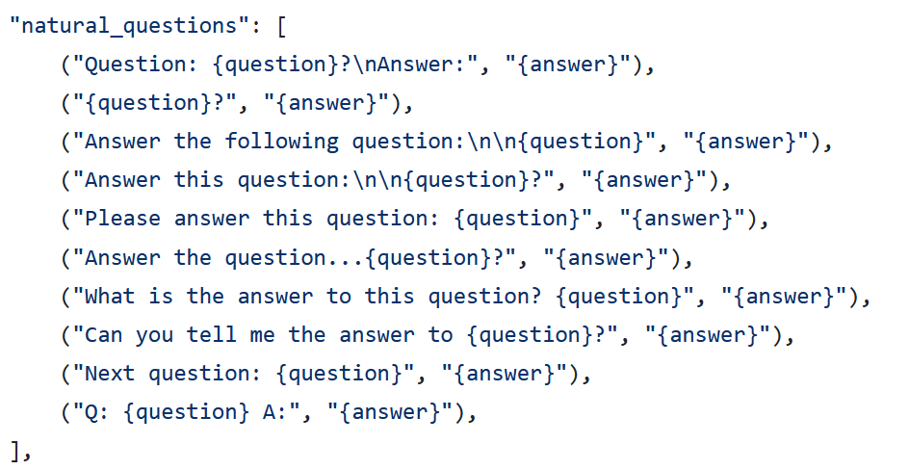

Next, we will ask a different question: “When was Washington, DC founded?”

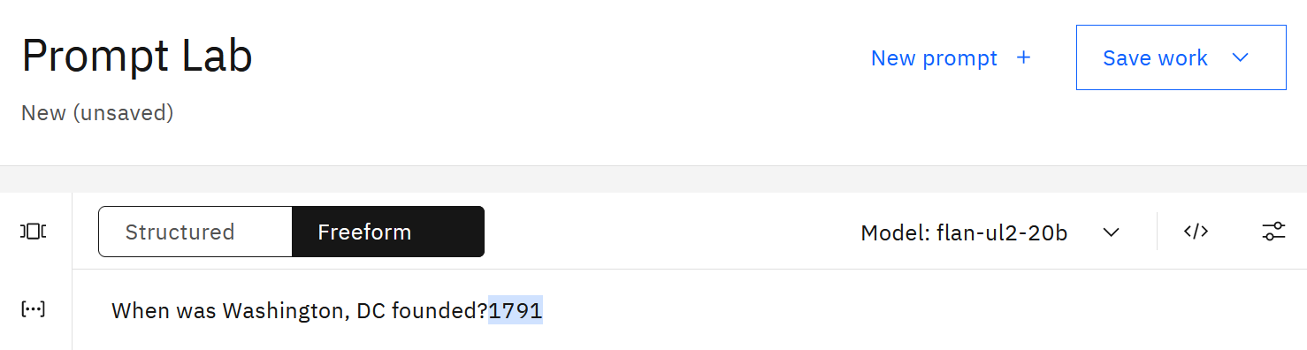

Double check if this is a correct answer by doing a traditional Internet search. You will find out that the correct answer is July 16th, 1790.

Next, switch the model to granite-13b-chat-v2, then llama2-70b-chat and ask the question again. This time we get the correct answer.

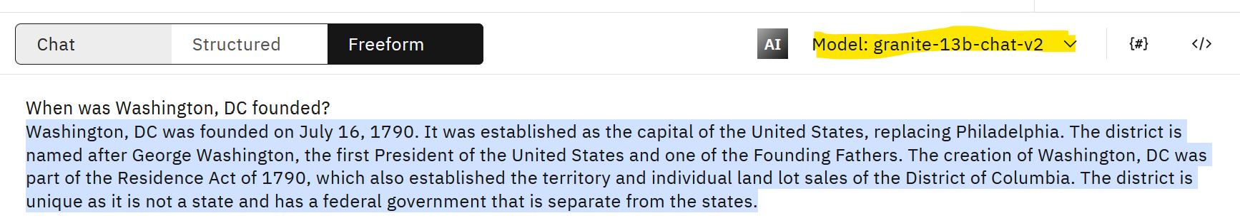

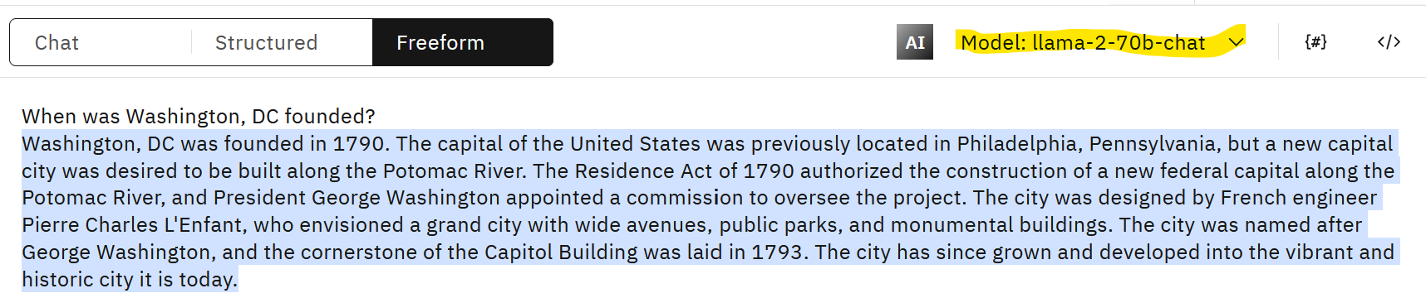

In general, this was not a simple question because at the time of writing conflicting dates are listed on the Library of Congress website and Wikipedia. Library of Congress is a more credible source, and in this example the Wikipedia page, which may have been used for model training of the flan model, has the incorrect date.

We provided this example to highlight the fact that the primary usage of LLMs should not be general knowledge question and answer. The quality of LLM output depends on the knowledge base that it was trained on. If we asked another question, it’s possible that flan would outperform other models.

We should think of LLMs as an “engine” that can work with unstructured data rather than a “knowledge base”.

When you first start working with LLMs, you may think that some models are not returning the correct response because of the prompt format. Let’s test this theory with the flan model.

Enter this prompt in the Prompt Lab:

Answer the question provided in '''.

Question: '''When was Washington, DC founded?'''

Answer:

Let’s review why we constructed the prompt in this format:

  - Triple single quotes (‘’’) are often used to identify a question or text that we want the LLM to use. You can choose other characters, but avoid “ (double quotes) because they may already be in the provided text
  - Notice that we provided the word “Answer:” at the end. Remember that LLMs generate the next probable word”, and providing the word “Answer” is a “hint” for the model.

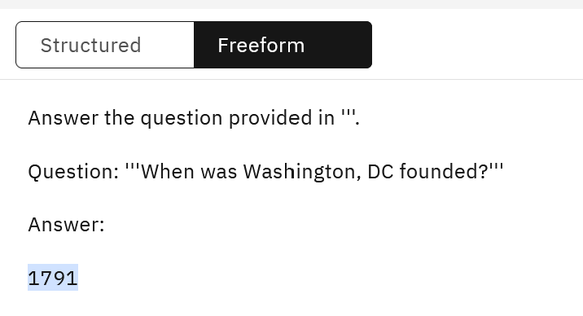

Unfortunately, we did not get a more accurate result from the flan model.

We will try one more approach, this time with a different prompt, which you can copy from Washington_DC_prompts.txt in the Lab_Files/Prompts folder.

- Copy Prompt 1 (flan) from the .txt file and paste it to the Prompt Lab.

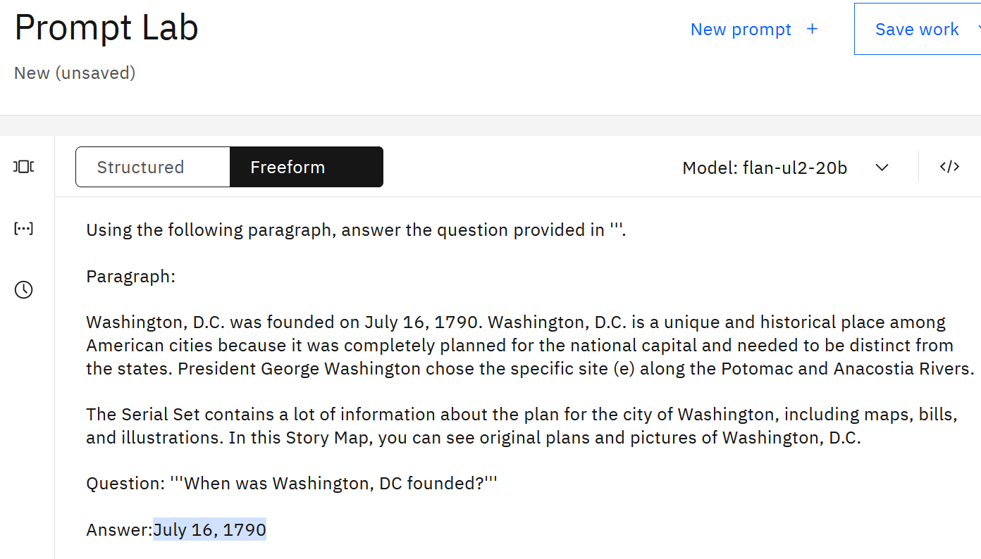

While this example may seem simple because we provide the answer in our prompt, it demonstrates one of the key use cases for LLMs, which is called Retrieval Augmented Generation (RAG). With RAG, we ask LLMs to answer questions or generate content based on the information that we provide. In our example we hardcoded content in the prompt, but it is also possible to implement RAG with automatic information retrieval from various knowledge bases, such as Websites, documents, emails, etc. In this case, the main feature of an LLM that we are interested in is “understanding” and not “knowledge”.

We used a simple example to ask a trivia question, but think about topics that may be relevant to your business for which “general information” may also exist, for example:

- What are the steps to get a driver’s license?
- What are the steps for submitting a car insurance claim?
- How can I close a credit card?
- How can I improve my credit score?
- Will an airline reimburse me for a canceled flight?

Most LLMs will be able to answer these questions because they were trained on data available on the Internet, but if you want the correct answer to your question, in most cases you will need to use RAG, i.e. provide information from your company’s data sources.

Watsonx.ai supports several implementations of RAG. We will cover it in more detail in one of the other labs.

Next, we’ll test prompts that generate output.

- Click on the model parameters icon in the top right corner of the Prompt Lab.

If you would like to learn more about each input in the Model parameters panel, you can review documentation.

Change the Max tokens to 500. When LLMs process instructions and generate output, they convert words to tokens (a sequence of characters). While there isn’t a static ratio for letter to token conversion, we can use 10 words = 15 to 20 tokens as a rule of thumb for conversion.

Use the flan model for your first test.

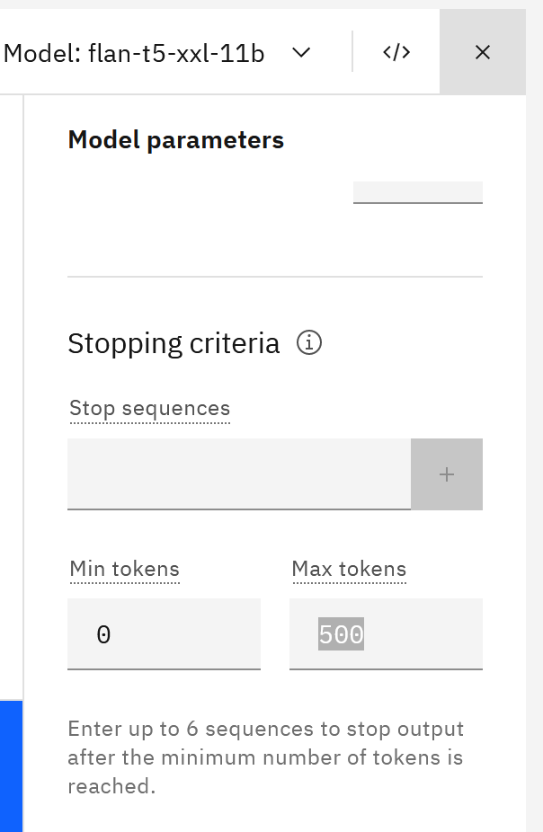

- Change the prompt to write a paragraph:

Write a paragraph about the capital of the United States.

Paragraph:

Notice that our output is rather brief.

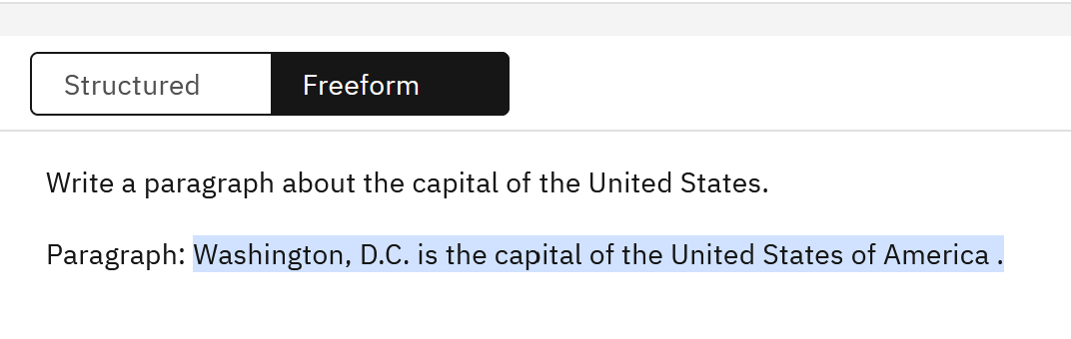
Next, we will try different model parameters and models to see if we can get better results.

- In the model settings switch Decoding from Greedy to Sampling. Sampling will produce greater variability/creativity in generated content (see documentation for more information).

Important: Make sure to delete the generated text after the word “Paragraph”: before clicking Generate again because the model will continue generating after any given text in a prompt, which may result in repetition.

Click the Generate button. It looks like we’re not getting better results with this model, so let’s try another one.



- Test the same prompt with the granite-13b-chat-v2 model. Delete the generated text and test again.

In our testing, we get better results with this model. Notice that every time you click Generate (after deleting the generated text), you get different results. We’re seeing this because we set the Decoding option to Sampling. You can also try Sampling with different temperature (higher value will result in more variability).

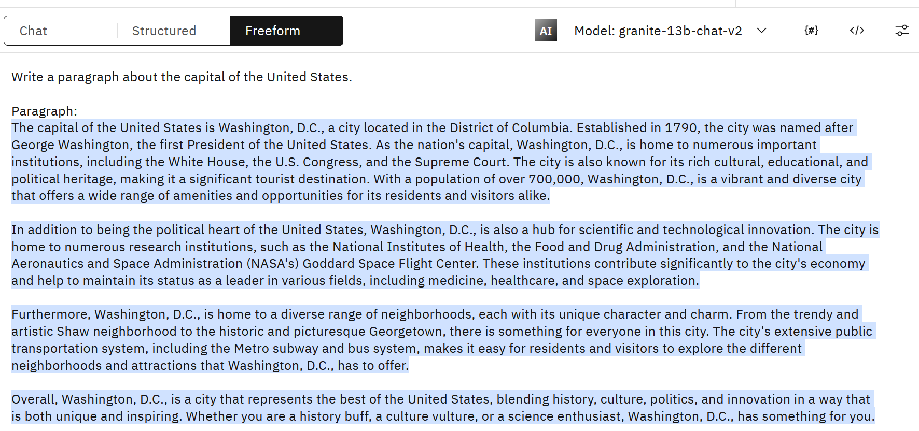

While it may seem unusual that the model generates a different output each time, it’s what we are instructing the model to do by both giving it instructions (“write”) and setting model parameters (“sampling”). We would not use the same instructions/parameters for a classification use case which needs to provide consistent output (for example, positive, negative, or neutral sentiment).

- Finally, try the llama model. For “creative output” use cases, llama usually produces production-quality output.

While you can you use the same prompt, we should also be familiar with system prompt format in llama. Llama is one of the few models that accepts prompts in a specific format.

Enter this prompt (Prompt 2), which you can copy from the from Washington_DC_prompts.txt
in the Lab_Files/Prompts folder.

<s>[INST] <<SYS>>
You are a motivational speaker.
<</SYS>>
Please write a paragraph to motivate a tourist to visit Washington, DC [/INST]

Important note: If you decide to use this format for llama, make sure not to put anything after the [/INST] In this format you do not need to give the model a “hint” (Answer: to generate the answer, etc.), like you’ve done in other examples.



As you can see, using the system prompt in llama is simple – it requires us to encapsulate the entire prompt in [INST][/INST] and add [SYS] if we want to give “general behavior instructions” to the model. The creators of llama recommend that this format is used for the best results, but it is not required.

Like the first prompting exercise, we started with LLMs’ general knowledge for generating output. In a business use case scenario, we would give LLMs a few short bullet points and ask it to generate output.

- If you wish to continue with the Washington, DC example, you can try Prompts 3 and 4 from the sample prompt file.

Notice that while IBM’s granite model does not require a specific format for a system prompt (for example, Act as a Marketing Consultant), you can still specify it in the free text.

Since IBM developed the granite model, the detailed instructions for prompting best practices are available in IBM documentation. If you’re working with an open source model, prompting best practices are often documented by the larger data science community and, in some cases, by the vendor who developed the model.

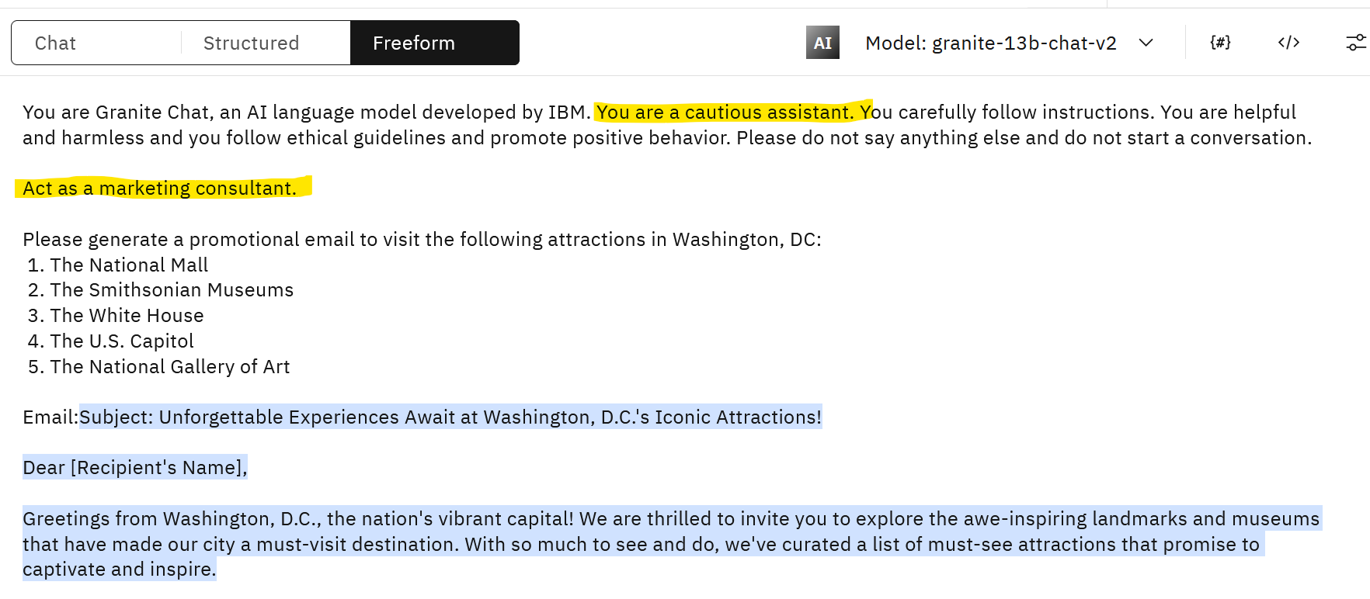

Some LLMs can follow instructions and generate output in multiple languages. Most LLM providers will document supported languages in the model card on Hugging Face or on the company’s website.

- In the Prompt Lab, click on the model dropdown and find the granite-20-b-miltilingual model.

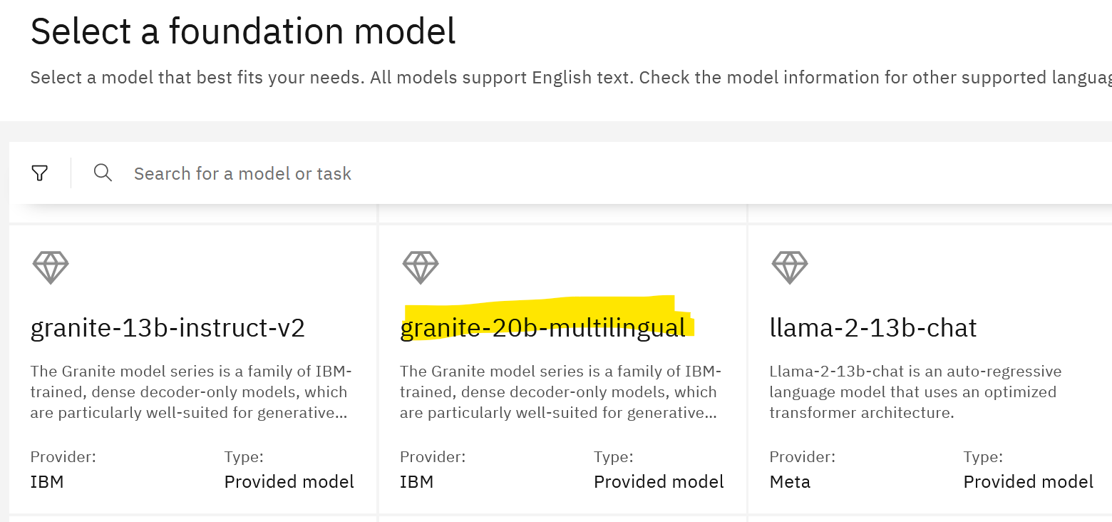

Review the model card and notice that the supported languages are listed in the model documentation.

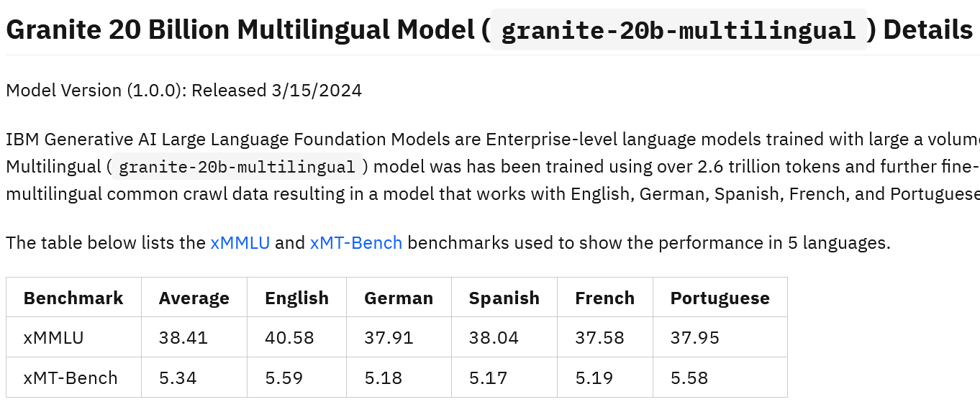

- Select this model and make a slight change to our last prompt – ask the model to generate the promotional email in French.

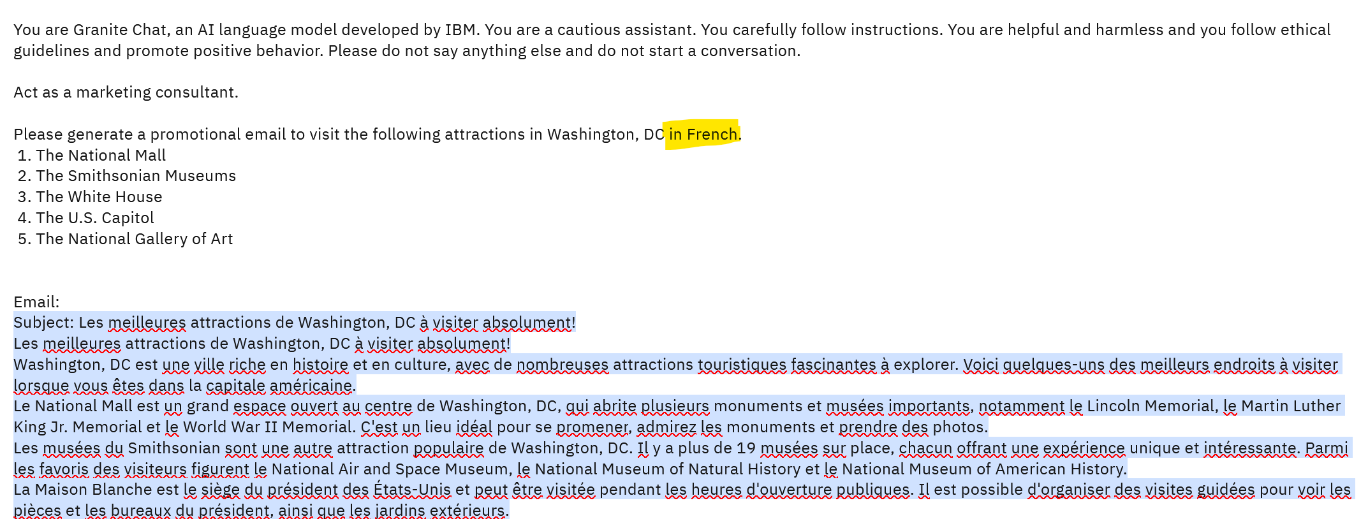

Another popular multilingual model is the open source model mixtral-8x7b-instruct-v01-q.

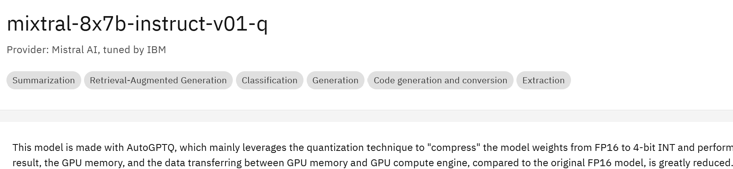

When you look at the Model card for this model, supported languages are not listed. In watsonx we publish model information provided by the model provider to Hugging Face without adding any additional information. In some cases, we may need to do additional research to find out if a model supports additional languages. From the Mixtral website we learn that the open source model supports several languages.

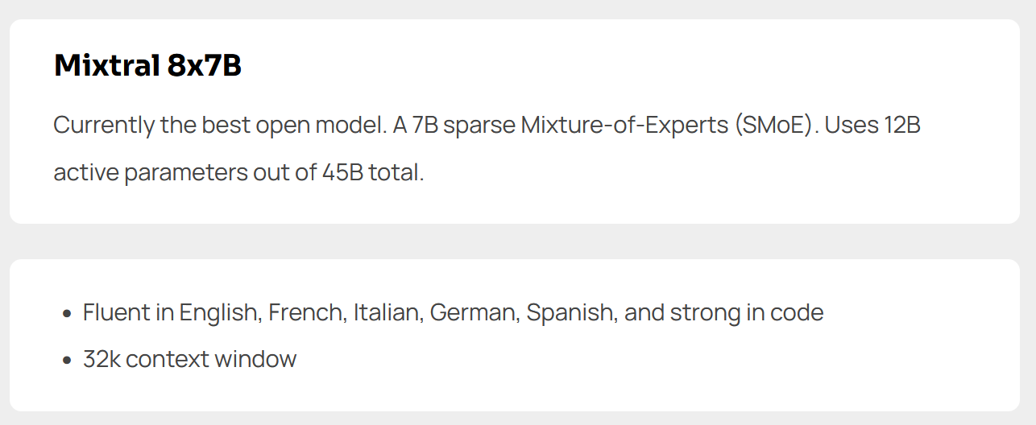

If you wish, try the previous prompt with the mixtral model.

Note: While it’s a good idea to remove the IBM-related system prompt from the prompt, it does not impact mixtral output.

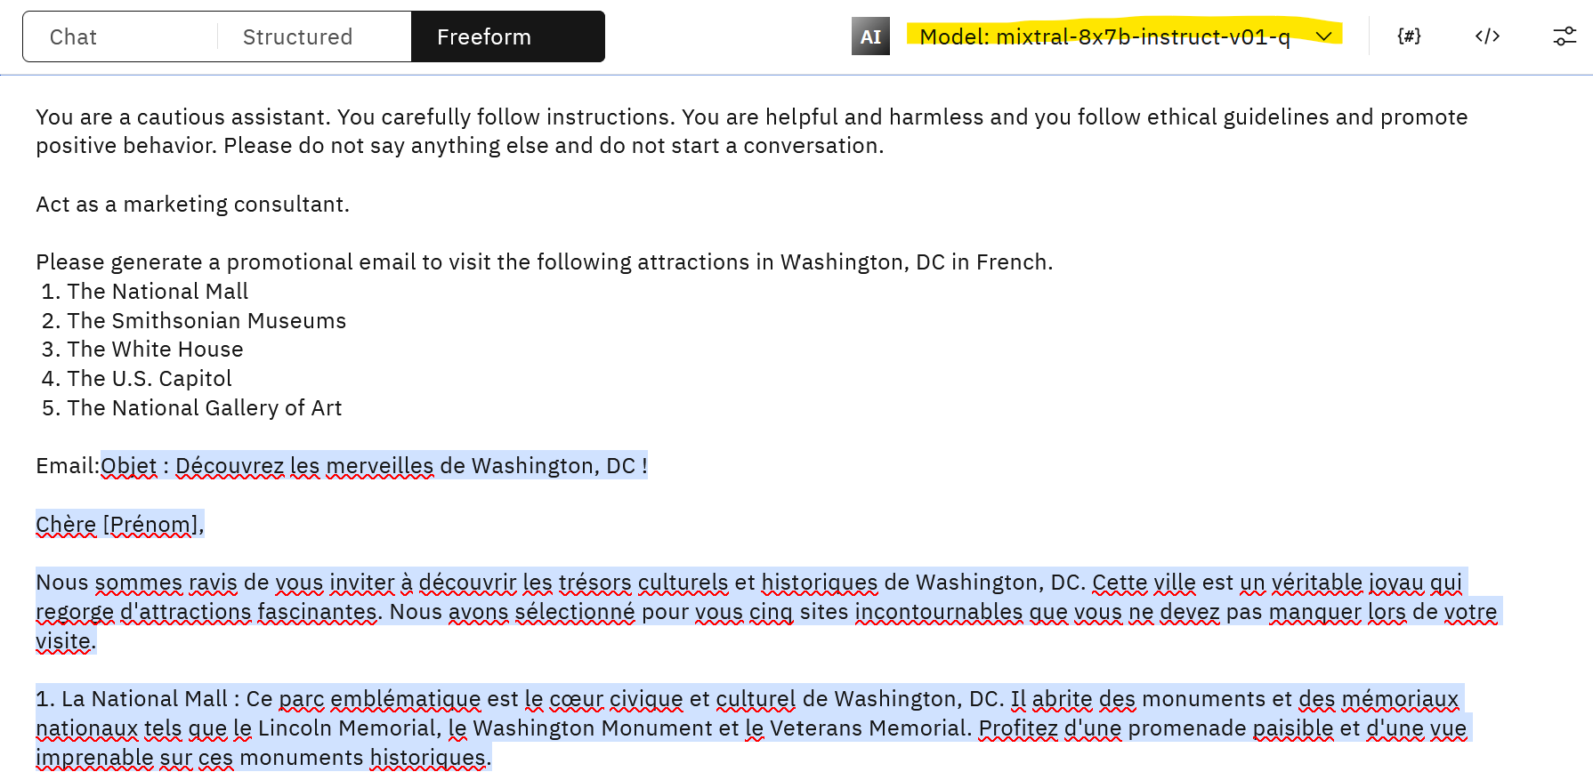

Next, we will look at the Sample Prompts included with the Prompt Lab. These samples implement some of the most common use cases in Generative AI.

- Click on the Sample Prompts icon and scroll down to the Marketing email generation example.

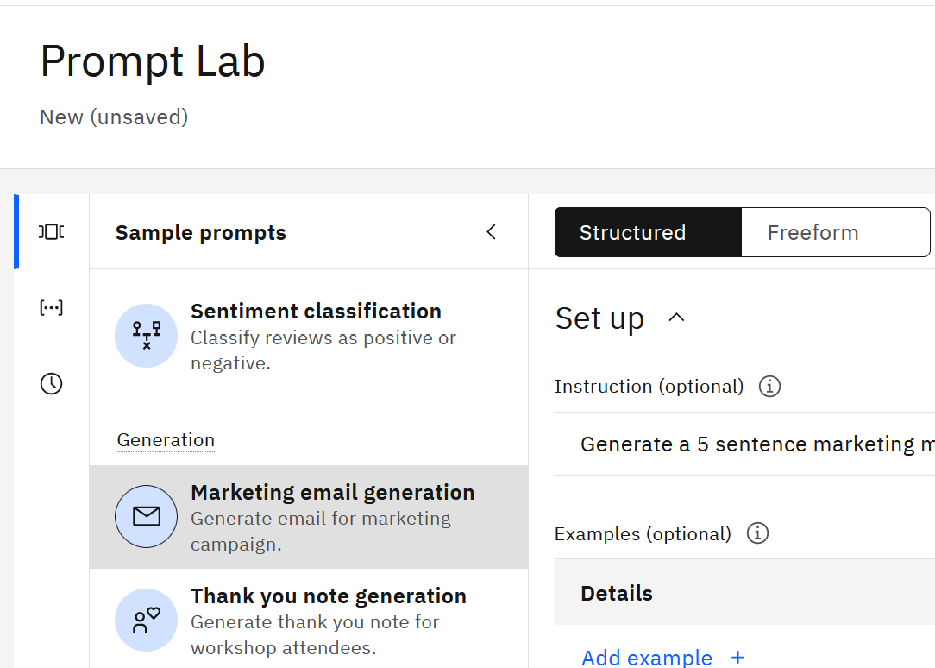

You can run this example from either the Structured or Freeform view. If you use the Structured view, the input for generation is shown under Details.

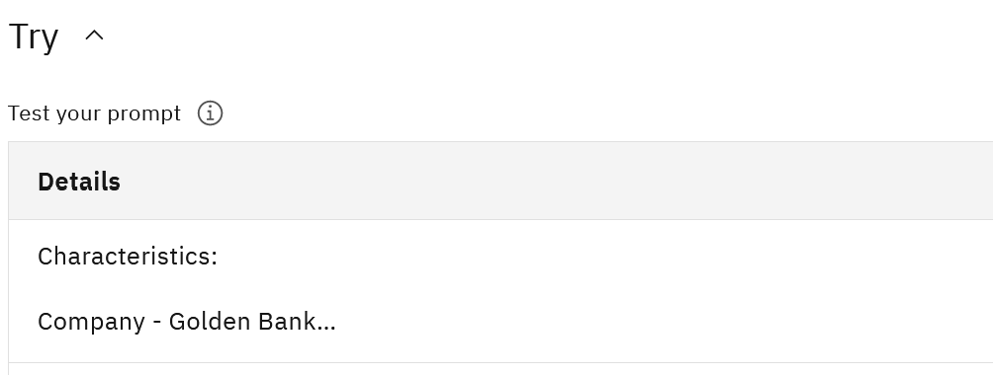

If you wish, change the input for the generated email and test the prompt.

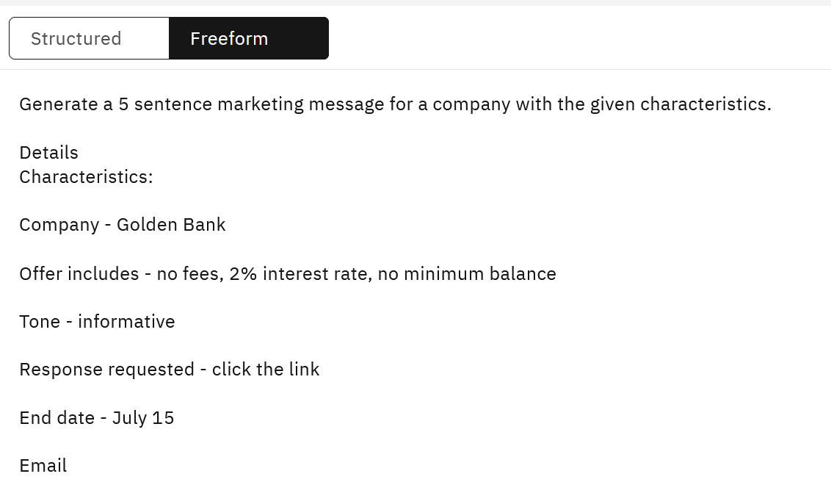

You may have already noticed that working with LLMs requires experimentation. In the Prompt Lab we can save the results of our experimentation with prompts

  - As a notebook
  - As a prompt
  - As a prompt session.

If we save our experimentation as a prompt session, we will be able to access various prompts and the output that was generated.

In the Prompt Lab, select Save work -> Save as -> Prompt session.

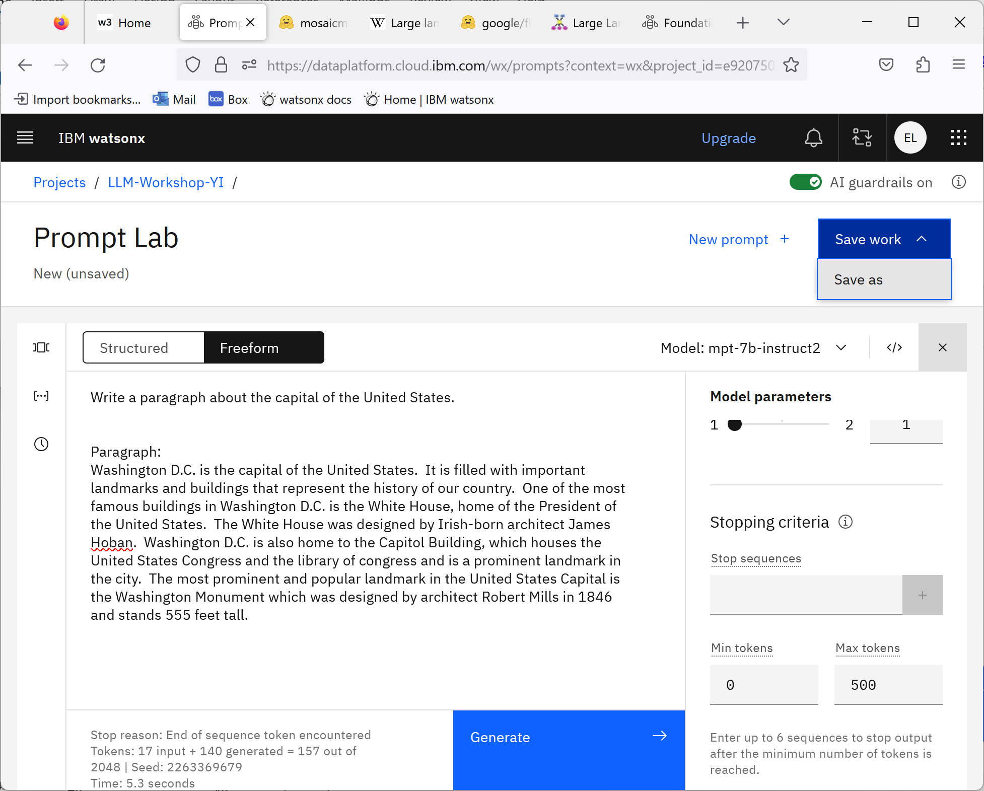

Name the prompt session Generate_paragraph.

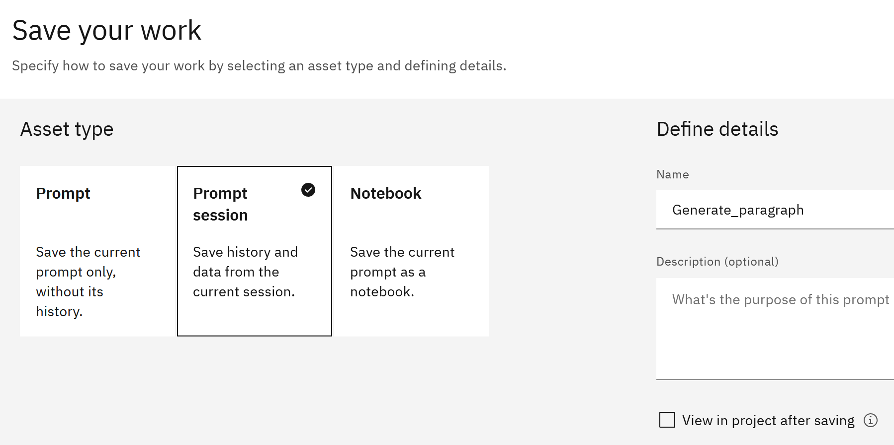

- Open watsonx.ai in another browser window and navigate to your project.

- Click on the Assets tab and open the prompt session asset that you created.

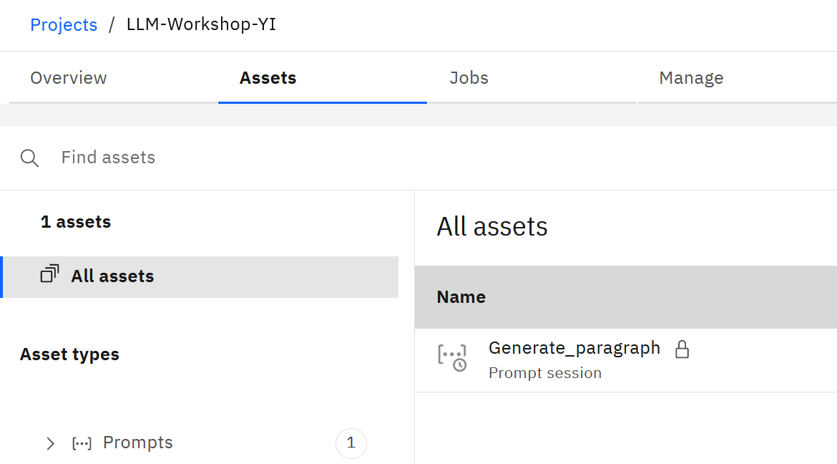

- In the Prompt Lab, click on the History icon.

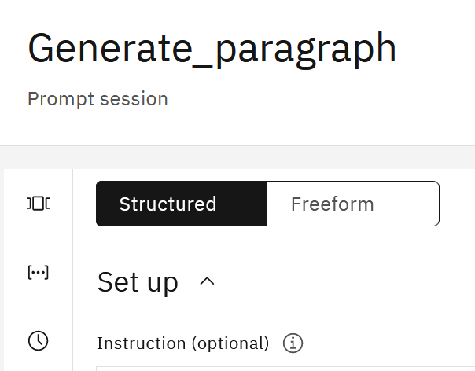

Notice that you can click on various prompts that you tested and view the output in the Test your prompt section of the Prompt Lab.

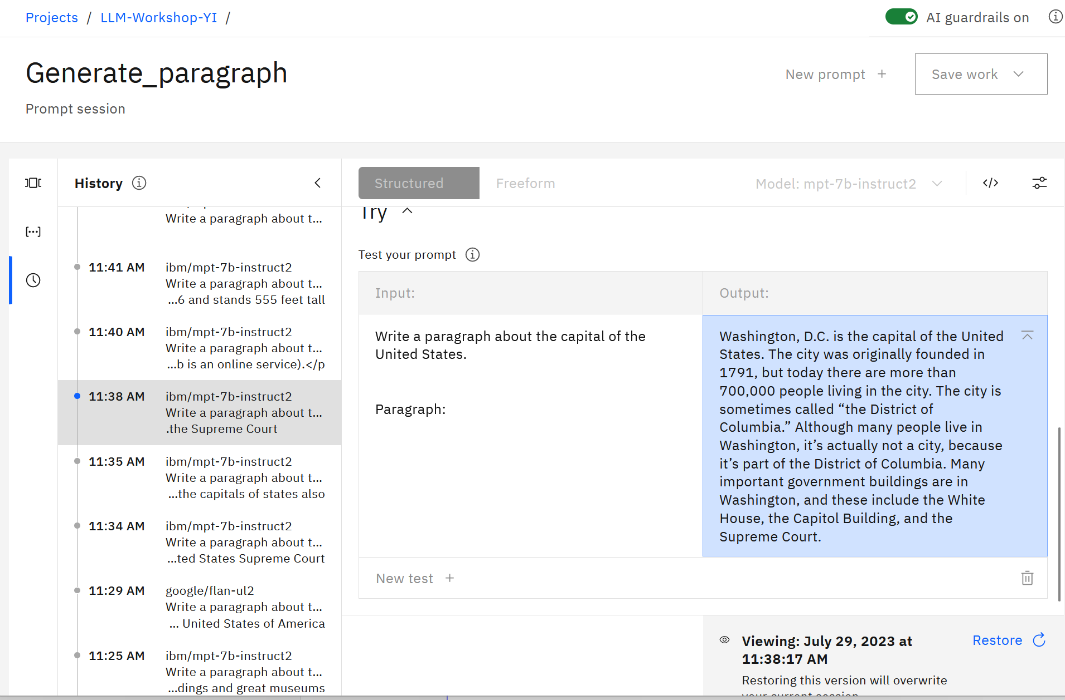

Close this browser tab and return to the Prompt Lab.

What you have tried so far is a “question and answer and generation use case with zero-shot prompting” – you’ve asked the LLM to generate output without providing any examples. The majority of LLMs produce better output when they’re given a few examples. This technique is called “few-shot prompting”. The examples are provided in the prompt after the instruction.

Let’s test few-shot prompting for various use cases.

- In the Prompt Lab, create a new prompt. Switch to Freeform, and paste the following prompt (this prompt is available in the Paragraph_few_shot.txt file in the /Prompts folder).

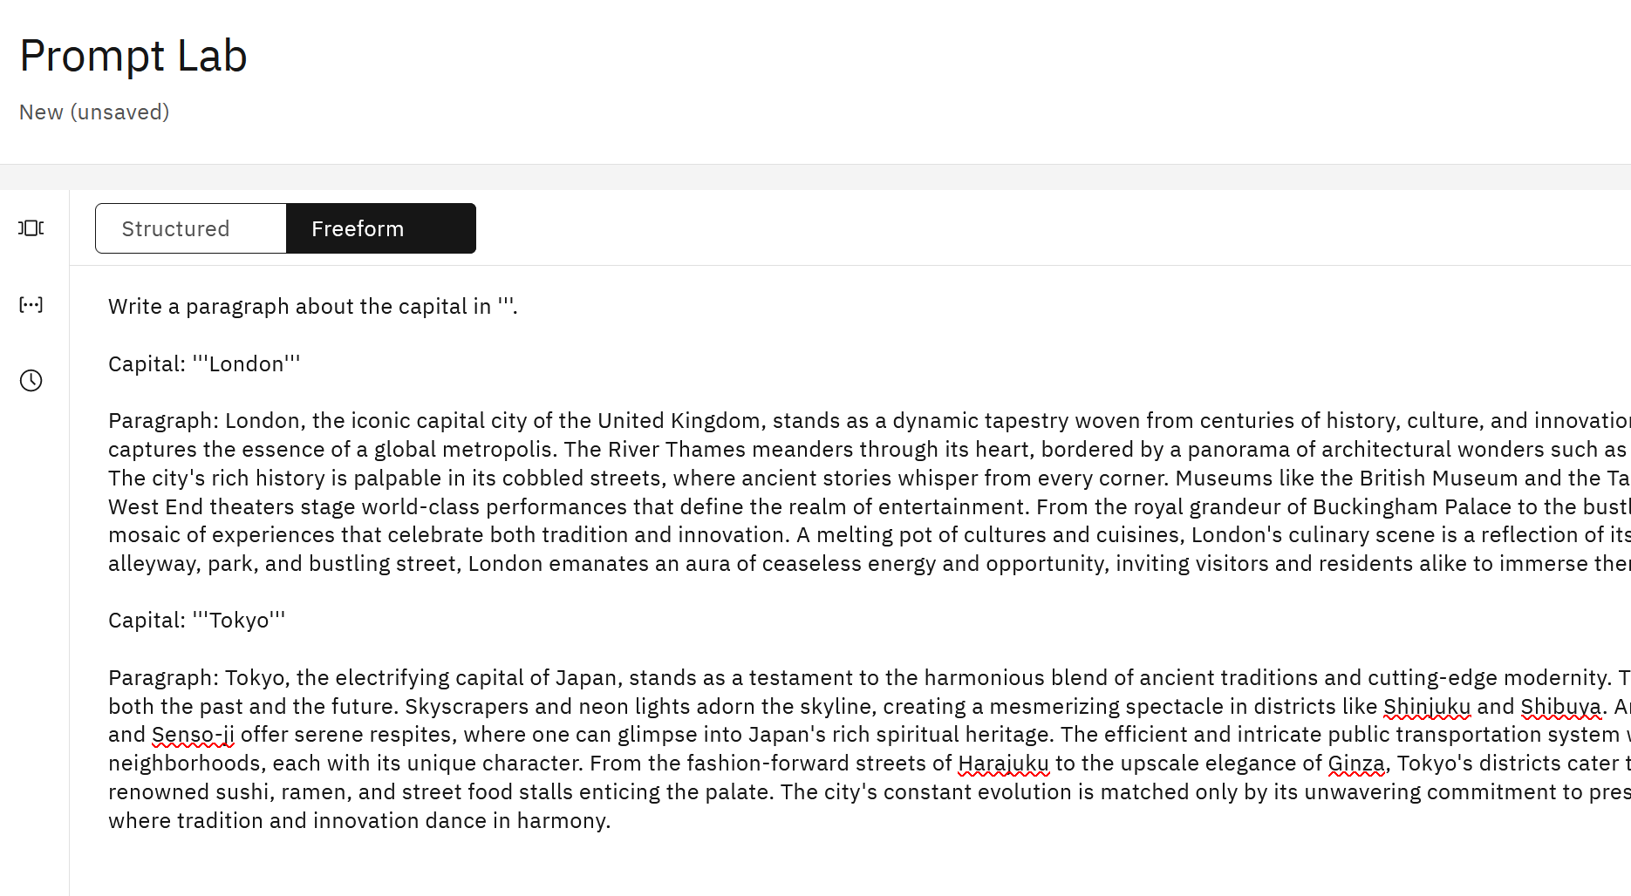

- Modify model parameters:

  - Change decoding to sampling (for more creative output)
  - Change the min and max number of tokens to the output you would like to see (for example, 50 min and 500 max)
  - If you wish, you can test different models.

Test the model and review the output.

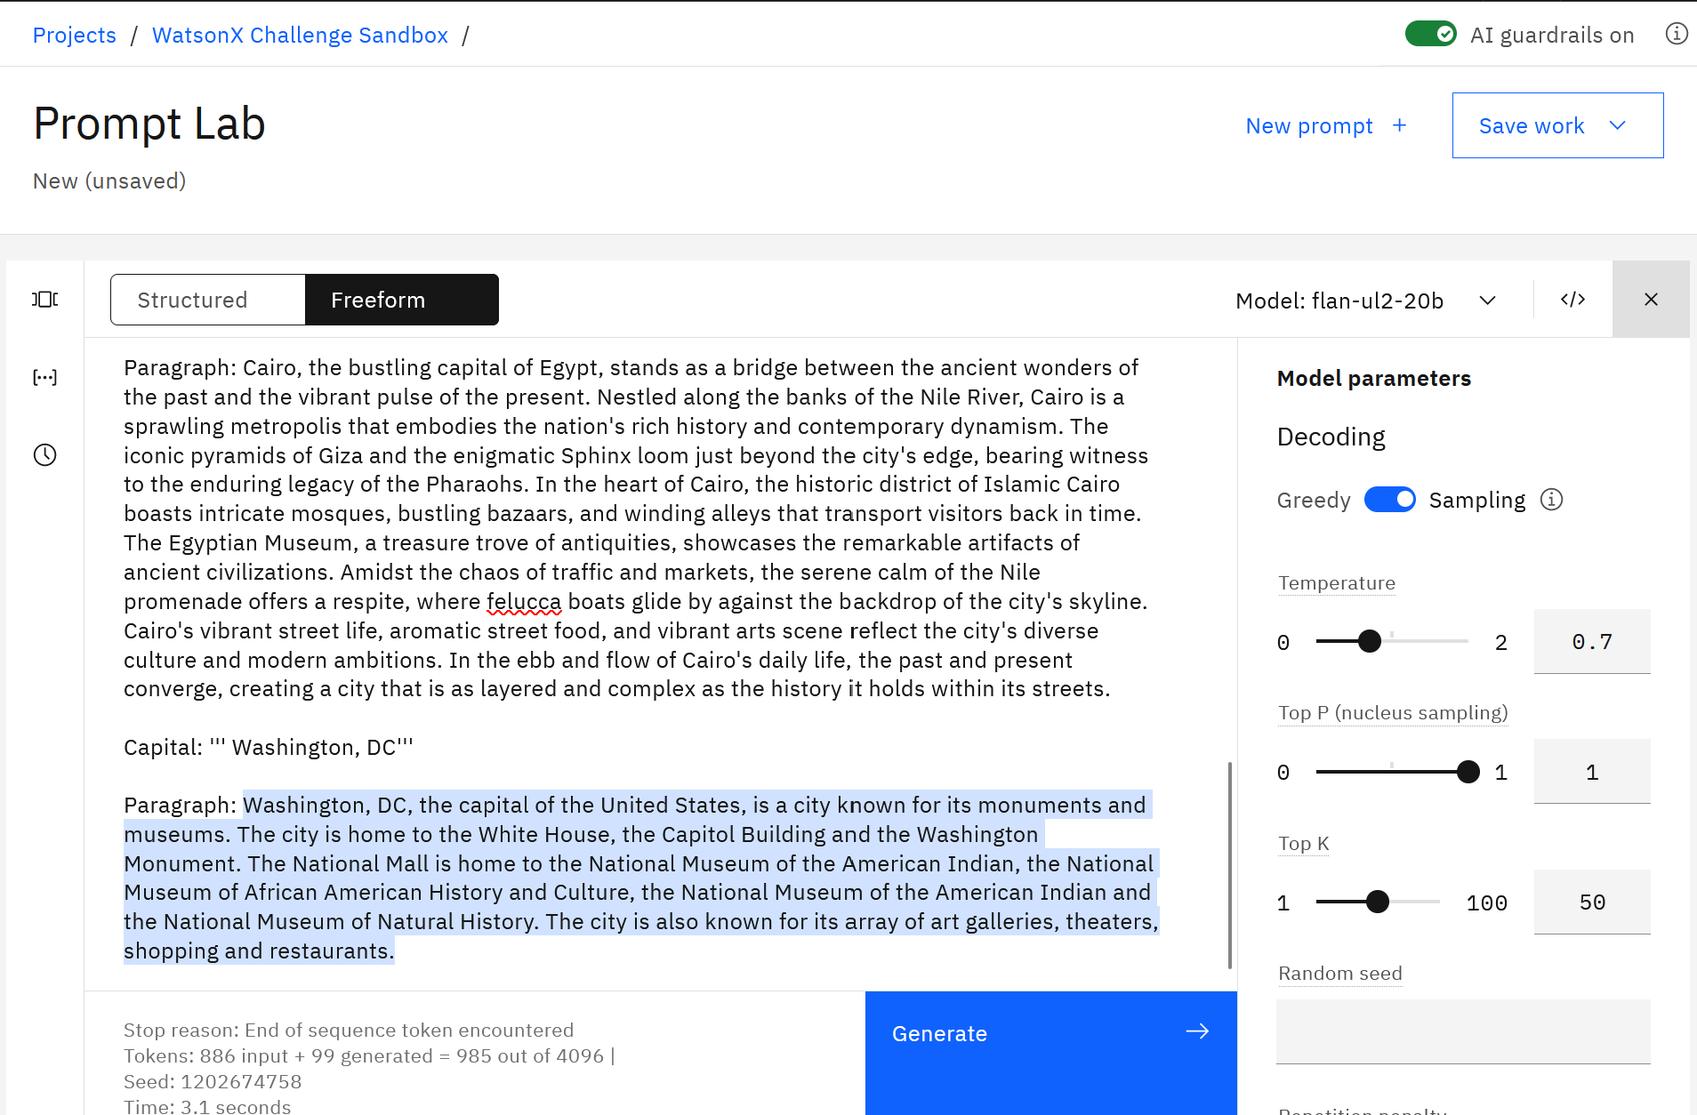

Next, we will review the concept of tokens.

- Notice the token count that’s shown on the bottom of the model output.

In the screenshot of this model output, the “out of” number (2048) shows the maximum number of tokens that can be processed by a model. If you test with a different model, the maximum number of tokens will be different.

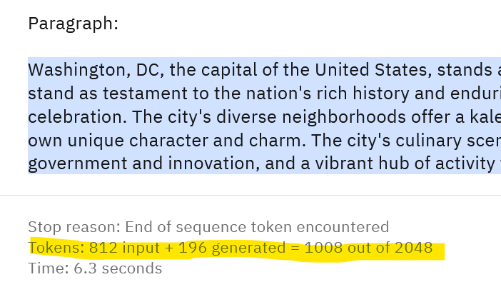

It is important to understand the following facts about tokens:

- All LLMs have a limit for the number of supported tokens. The maximum number of tokens is usually captured in documentation or the UI, as you’ve seen in the Prompt Lab.
- The maximum number of tokens includes both input and output tokens. This means that you can’t provide an unlimited number of examples in the prompt. In addition to that, each model has the maximum number of output tokens (see documentation).
- Some vendors have daily/monthly token limits for different plans, which should be considered when selecting an LLM platform.

Example of token limits (from documentation):

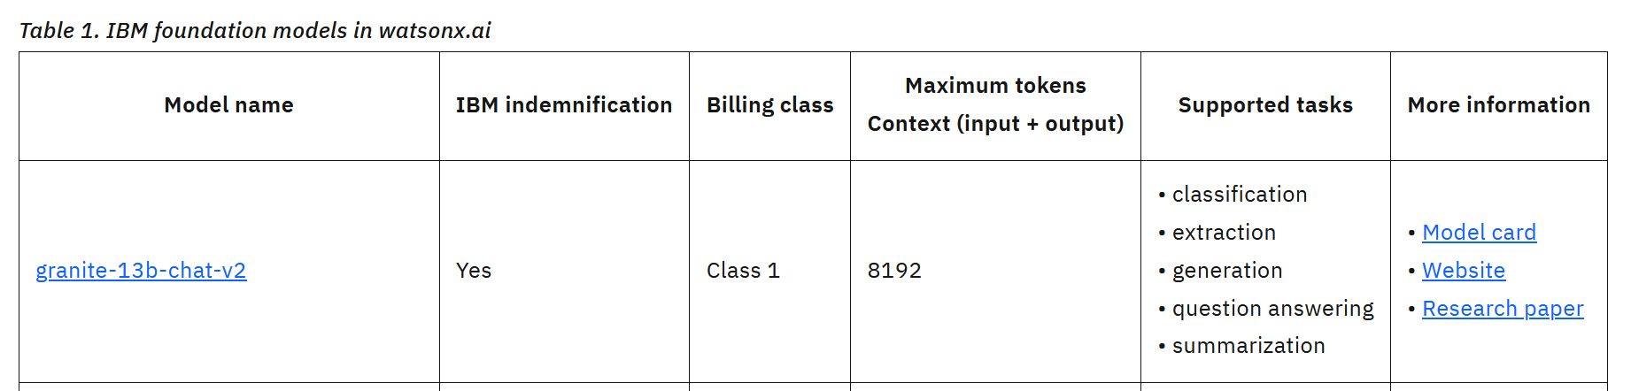

Understanding token constraints is especially important for summarization, generation, and Q&A use cases because they may require more tokens than classification, extraction, or sentiment analysis use cases.

The token constraint limitation can be solved with several approaches. If we need to provide more examples to the model, we can use an approach called Multitask Prompt Tuning (MPT) or fine-tuning. We are not covering these advanced approaches in this introductory lab.

Up to this point, we reviewed question & answer and generation examples. We started with these examples because for most users they are the “first experience” with generative AI. Many people are familiar with ChatGPT, a popular personal assistant application developed by OpenAI. Sometimes the terms generative AI and even LLM are used interchangeably with ChatGPT, but ChatGPT is more than an LLM, it’s a complex application that uses LLMs.

LLMs are building blocks or components of an application, and by themselves, they can rarely be used by a business user. ChatGPT is an application that focuses on personal productivity tasks for many types of users. Companies that want to build AI-driven applications need an AI development and deployment platform, such as watsonx.ai.

In our experience of working with clients, some of the top generative AI use cases are:
  - Content summarization
  - Content classification
  - Content generation
  - Content extraction, NER (Named Entity Recognition)
  - Sentiment analysis
  - Question answering with RAG

Let’s review sample prompts for a few more use cases.

- In the Prompt Lab, create a new prompt and click on the Sample prompts icon.

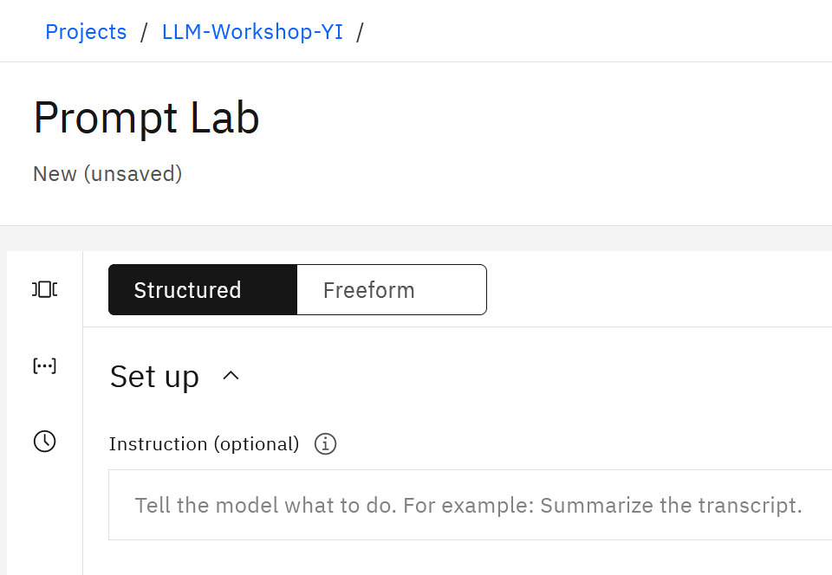

- Explore/test the different prompts, which are organized by use cases.

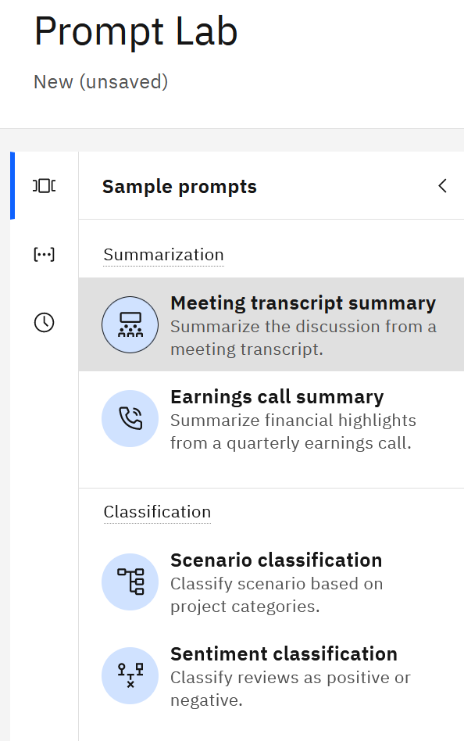

Notice that some examples use few-shot prompting (Meeting transcript summary), while others (Sentiment classification) use zero-shot prompting.

If you wish, try a few sample prompts that we provided in the downloaded Lab_Files/Prompts folder and sample prompts from documentation.

When you were using the Prompt Lab you may have noticed the Chat tab. Let’s review the capabilities of this feature.

By default, all LLMs are stateless – they do not have a “memory”, which is also called “state” in applications.

- In the Prompt Lab, try executing these 2 prompts sequentially with the llama model:

Prompt 1: Please generate an SQL statement that joins tables CUSTOMER and TRANSACTIONS on column CUSTOMER_ID
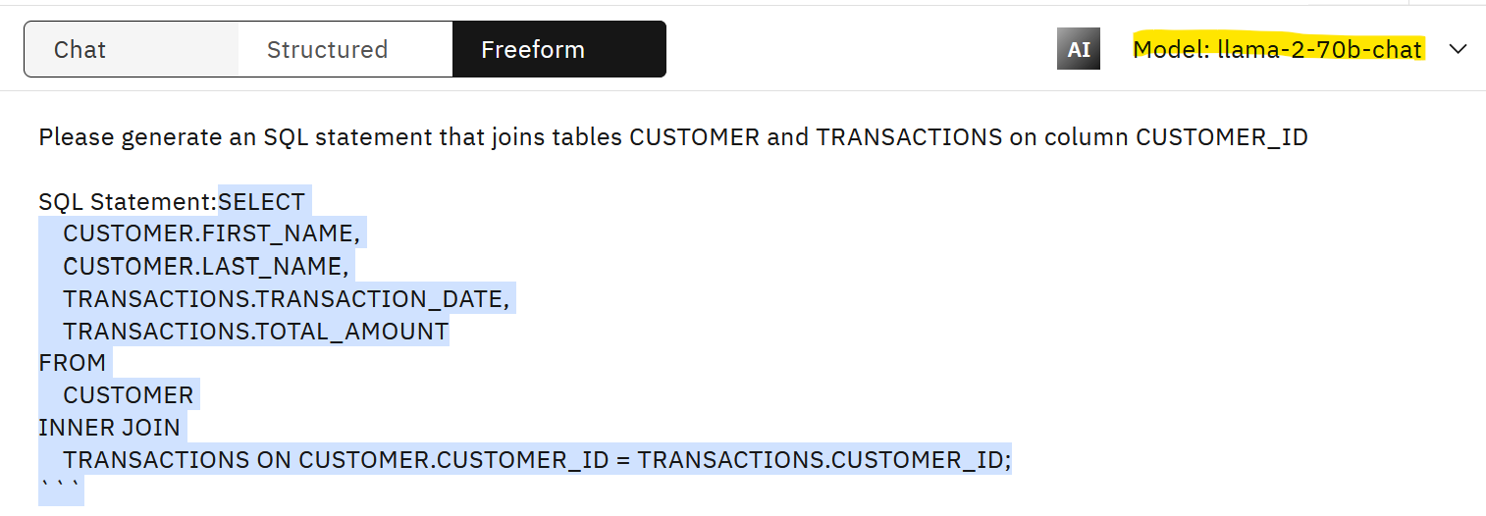

Prompt 2: Please generate Python code to invoke this statement accessing Netezza database.

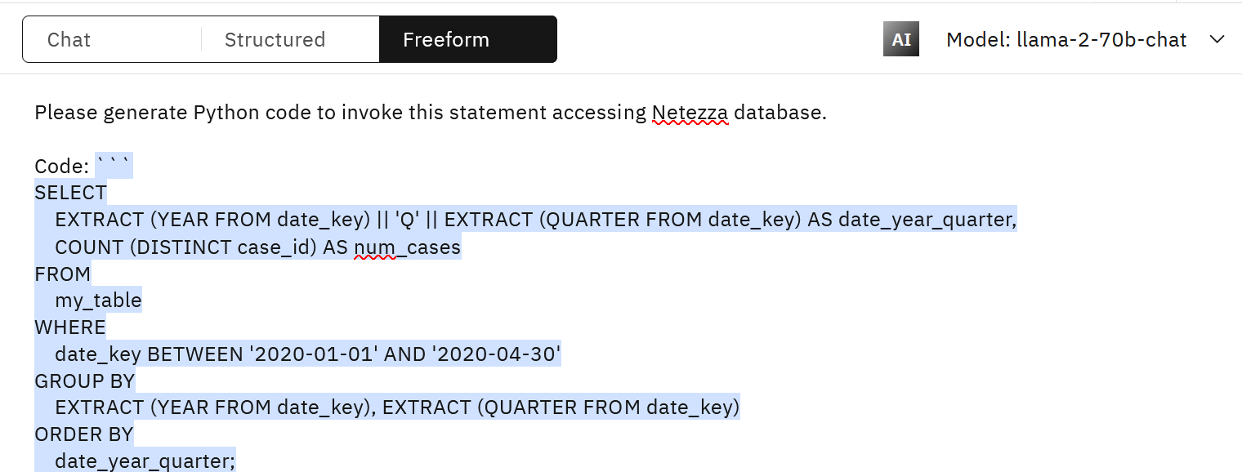

Note: While the prompts can be improved, we are not going to work on it at this time because we are focusing on the issue with memory.

You will not get meaningful results even from the best model because the model does not know what “this” (the preceding statement) means as it does not have a memory.

Now switch to the Chat mode in the Prompt Lab and try these two prompts again.

Output of the first prompt:

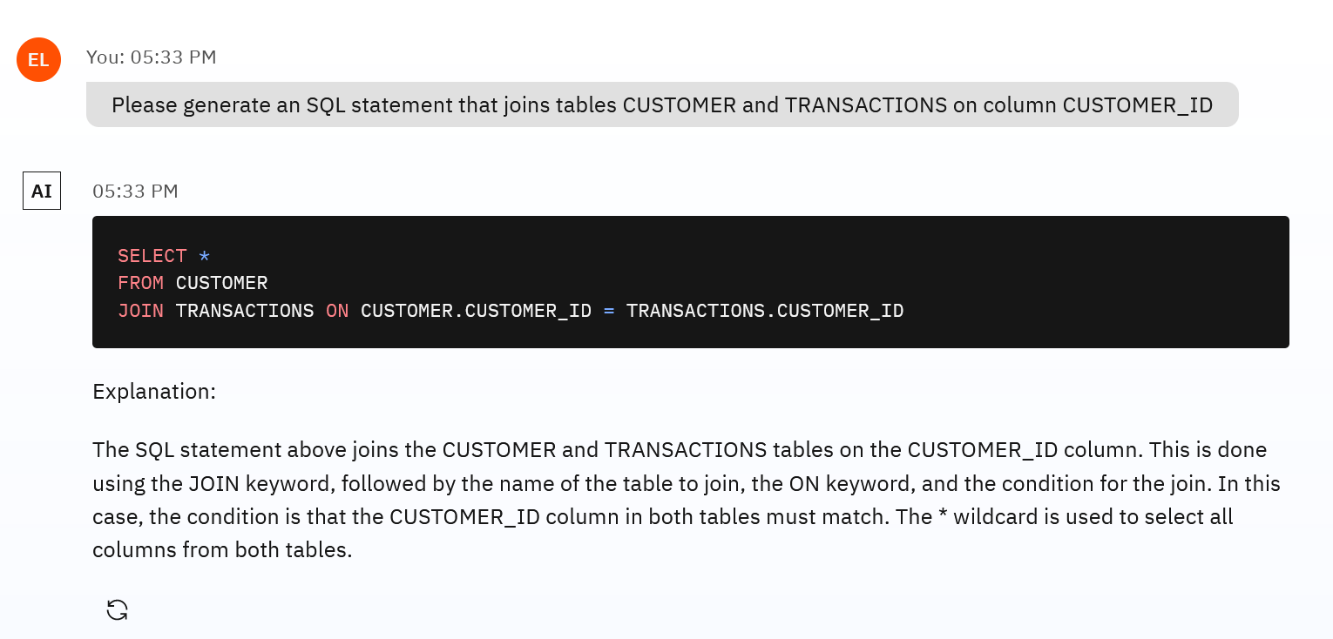

Output of the second prompt:

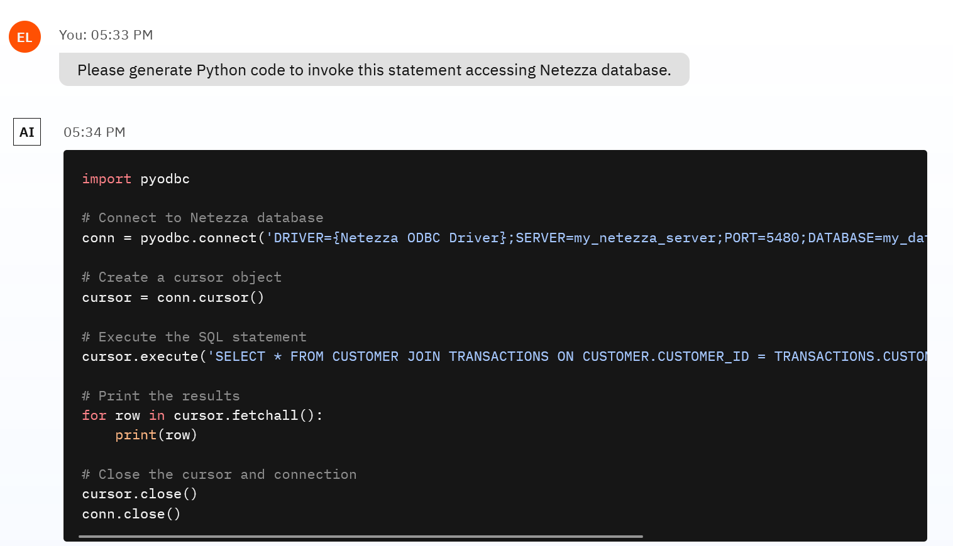

Notice that this time we got the correct Python code with the right SQL statement.

The Chat UI implements “memory” for LLM integrations. Memory implementation in applications that use LLMs is an intermediate complexity topic, and it is covered in more detail in other hands-on labs. On a high-level, memory in LLMs is implemented by appending the response from the previous prompt to the next one. This approach increases the number of tokens sent to the LLM each time, and eventually (usually after 3-5 interactions), we will reach the max number of tokens supported by most chat LLMs. This is a known constraint of working with LLMs, and application developers can use various techniques to solve it.

If you wish, open the code panel of the Chat UI to review the prompt. The shown prompt (included in the REST call) shows the last executed prompt.

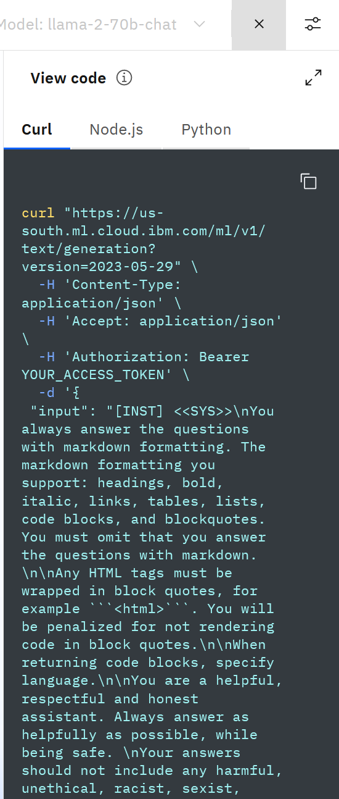

You can copy the prompt and paste it to a notepad to review the details.

The shown prompt is the last prompt that was executed. Notice that the first prompt and the output of the first prompt are included in the final prompt.

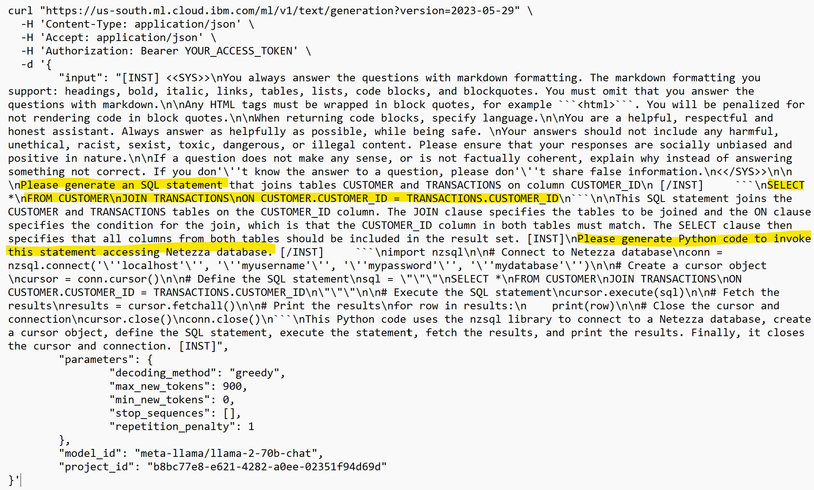

Another interesting part of this prompt are system instructions: to return output in markdown formatting vs. just the default text. When output is returned in this format, the integration with the UI (in this case the Chat UI interface) requires fewer lines of code.

Watsonx.ai does not provide a UI for end-user applications because UI is typically developed and hosted in other components of a solution. In the next section you will learn how to integrate LLMs with applications.

Summary:

Throughout this lab you have used both open source and IBM models. Some of the most popular open source models are llama, mixtral, and flan. IBM will continue to bring the best open source models to watsonx.ai. At the same time, IBM developed several LLMs which can offer several benefits to our customers.

Despite the significant interest in application build on LLMs, concerns around fairness, bias, and regulations remain a hurdle for their enterprise-wide adoption. To address these issues, IBM developed granite series of foundation models. Trained on enterprise-relevant content, granite models meet rigorous data governance and regulatory criteria defined by the IBM AI Ethics code and Chief Privacy Office. These IBM models provide improved accuracy for targeted business domains like finance and use cases such as RAG, achieved through chat fine-tuning and model alignment techniques. Additionally, granite models are cost-effective, with less infrastructure requirements, IP indemnification, and an easy-to-use toolkit for model customization and application integration.

Now that you have reviewed and created prompts, we will test the integration of LLMs with client applications.

Part 2: Integrate LLMs with applications
Up to this point you have completed a simple prompt engineering exercise. Prompt engineering is just one of the steps in the process of integrating LLMs into business applications.

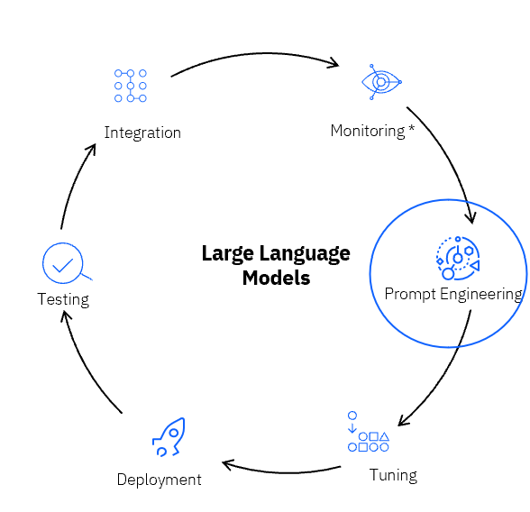

Let’s review other steps:
- There are several types of tuning, which are usually applied to improve model output. In many use cases tuning won’t be a required step.
- LLMs are pre-deployed (available for invocation out-of-the-box) in watsonx.ai. The only time deployment may be required is for tuned models.
- Testing and integration is done with either the REST API or the Python SDK.

In this section, we will review the testing and integration steps.

- Navigate to the Prompt lab and open one of the prompts you previously created or one of the sample prompts.

In this section, we will be using the loan summary prompt which you can find in /Prompts/Loan_few_shot_summary.txt.

- Generate a response using this prompt.

- You can use either the granite-13b-chat-v2 or the llama model (add the system prompt for llama)
- Keep the decoding method as Greedy
- Add a stop sequence of “.” to prevent output that ends with mid-sentence.
- Make sure to set the min and max tokens to 50 and 300.

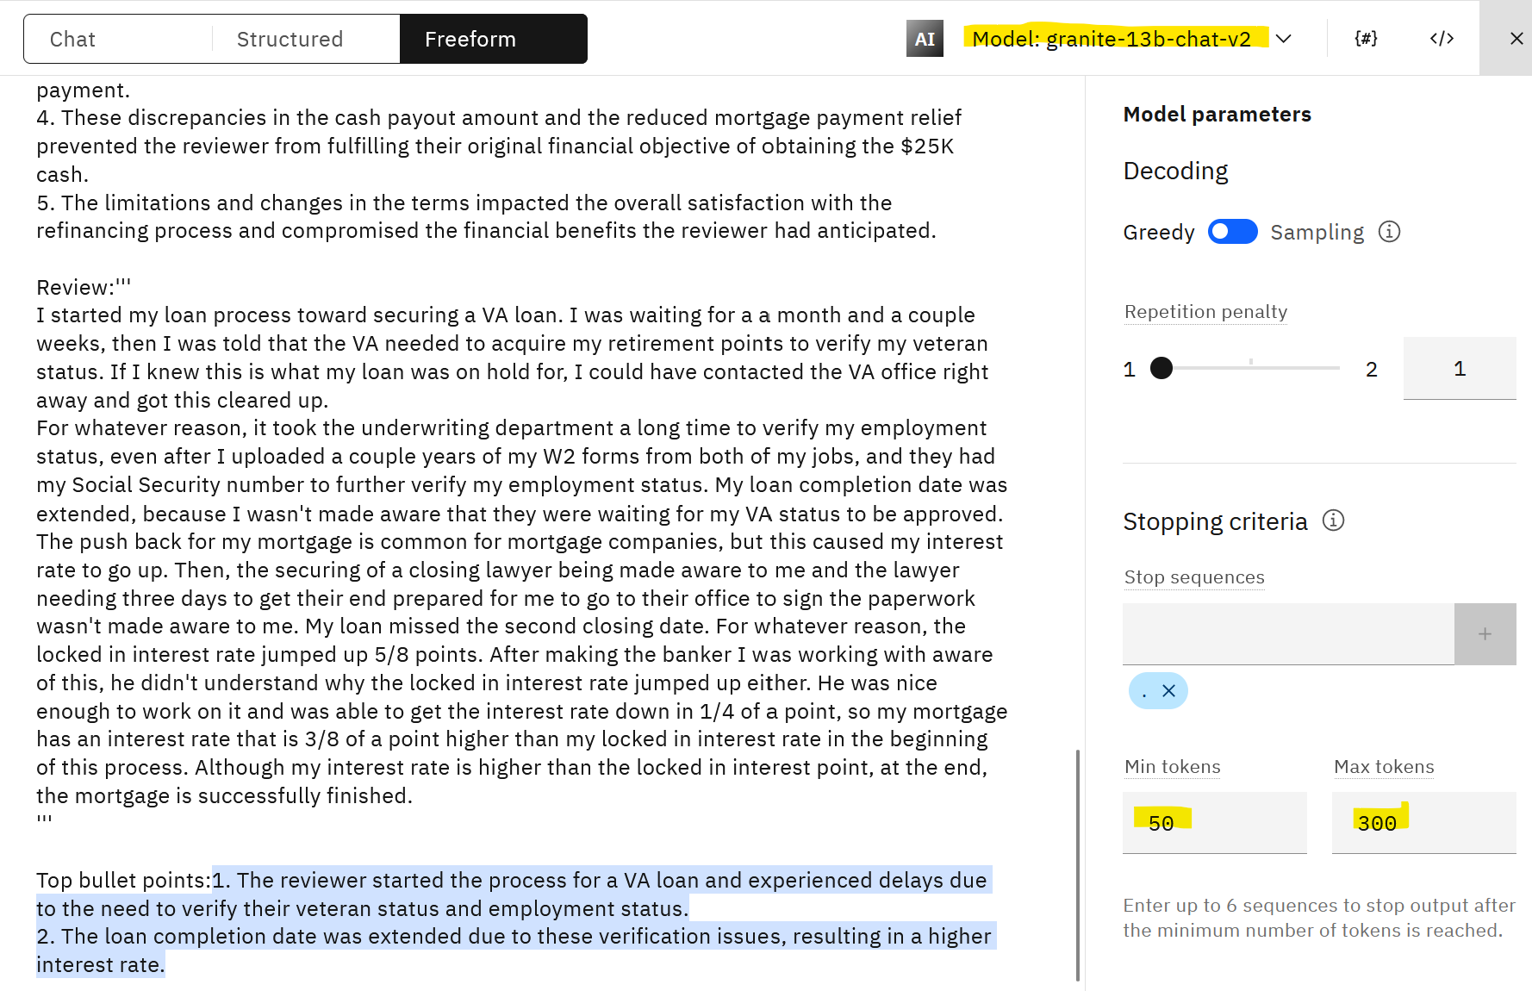

After testing the prompt (click Generate), click on the View code icon.



Copy the code to a notepad.

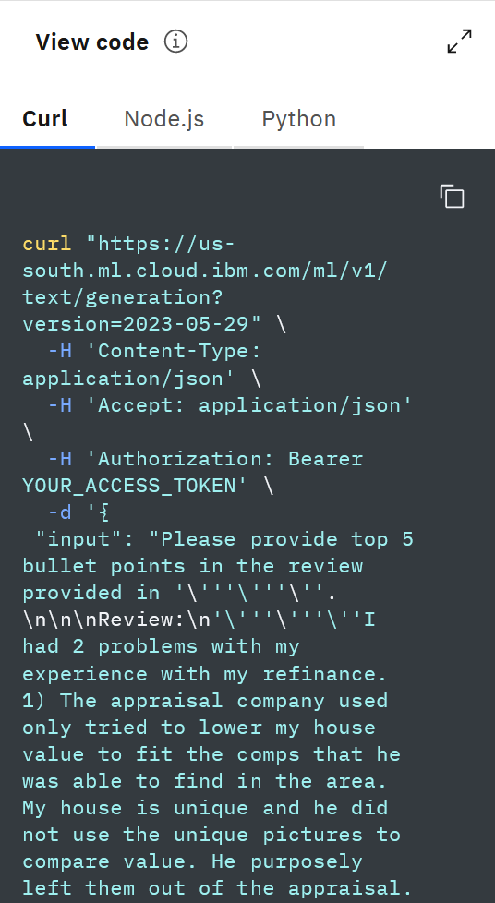

Let’s review the code.

This code is an example of a REST call to invoke the model. Watsonx.ai also provides a Python API for model invocation, which we will review later in this lab.

The header of the REST request includes the URL where the model is hosted and a placeholder for the authentication token. At this time, all users share a single model inference endpoint. In the future, IBM plans to provide dedicated model endpoints.

Note: IBM does not store model inference input/output data. In the future, users will be able to opt in to storing data.

Security is managed by the IBM Cloud authentication token. We will get this token shortly.

The body of the request contains the entire prompt.

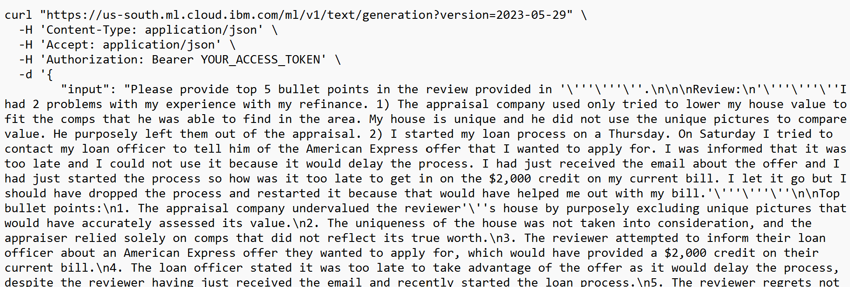
Body
Header

Finally, at the end of the request we specify model parameters and the project id.

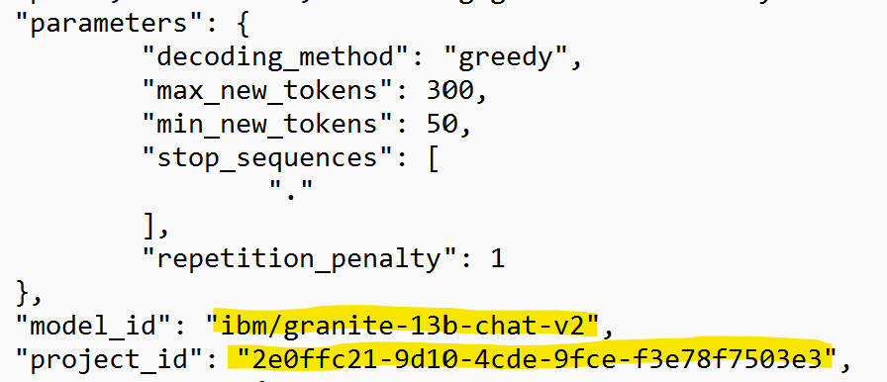

The project id can be looked up in the Project -> Manage view tab of the watxonx.ai project

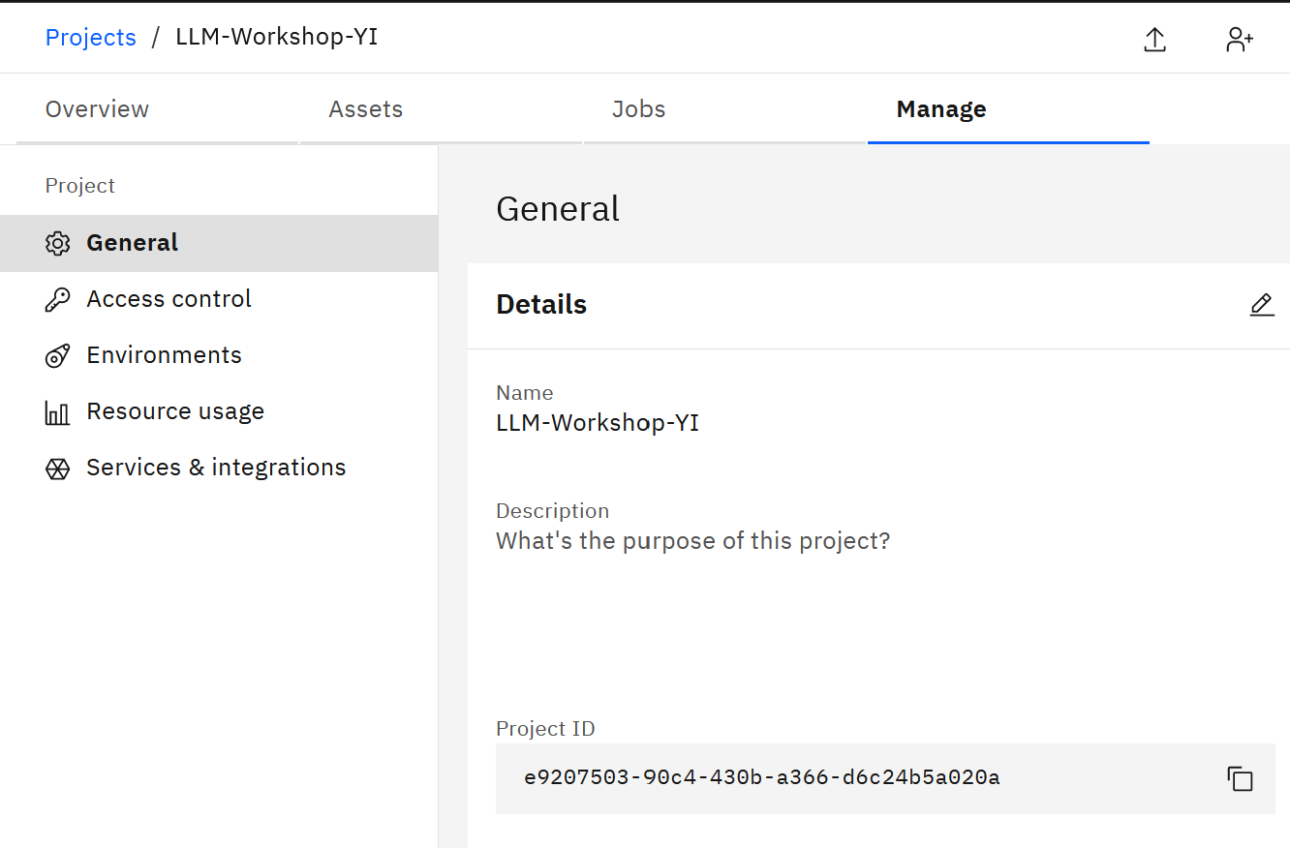

Now, we will get the authentication token.
- Open a new browser window and from the main watsonx menu (top left corner), select IBM Cloud.


- Select Manage -> Access (IAM).

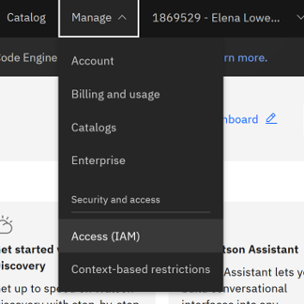

- Click API Keys -> Create. Give the token a name and save it in a notepad. You will use it in the sample notebook.

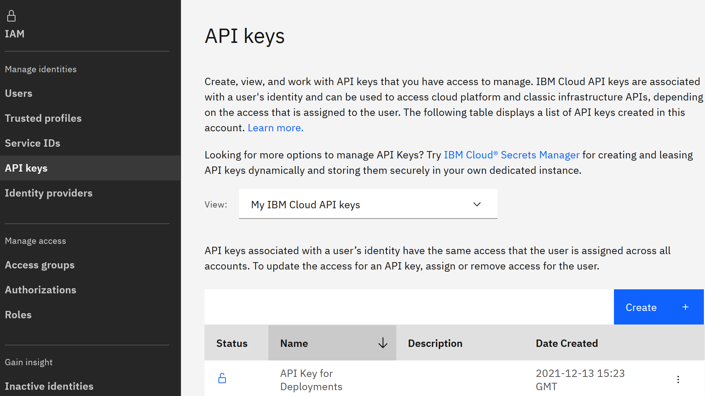

- In watsonx.ai click New Asset -> Work with data and models in Python or R notebooks.

Click the From file tab and navigate to the downloaded Lab_Files/Notebooks folder to select the TestLLM notebook. Make sure that the Python 3.10 environment is selected.

Click Create to import the notebook.

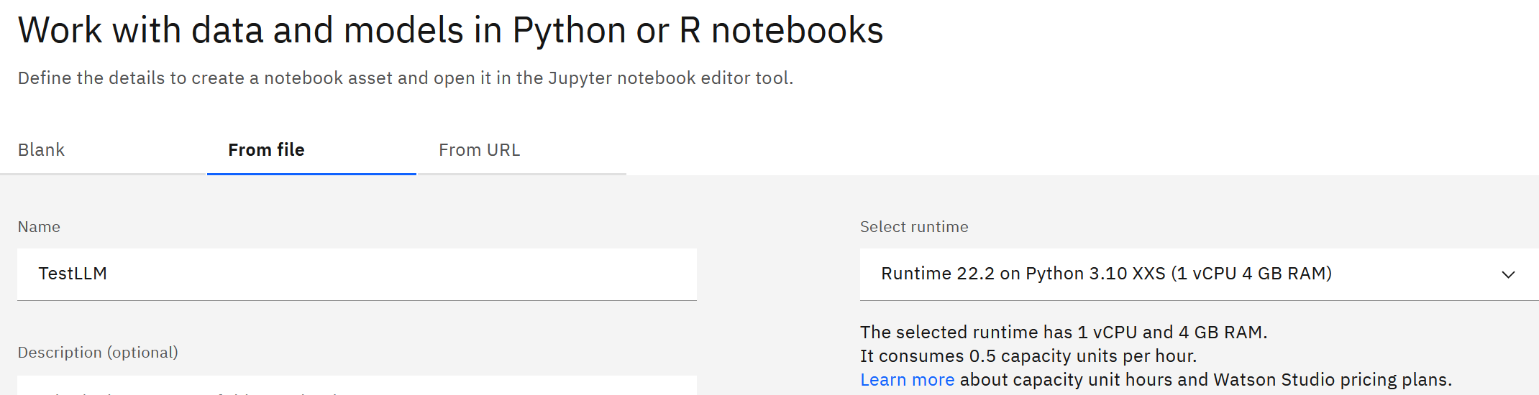

Let’s review the sample notebook.

This notebook acts as a client application that invokes the deployed LLM with a Python SDK. We are using the notebook as a client for simplicity of testing during this lab.

Enterprise client applications can be implemented in Python, Java, .Net and many other programming languages. As discussed earlier, LLMs deployed in watsonx.ai can be invoked either with REST calls or with the Python SDK.

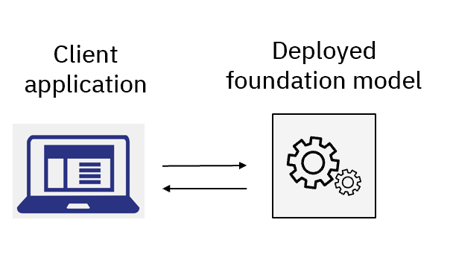
Run the notebook to test the LLM with your prompts. See specific instructions in the notebook.

Note: if you do not have a Python IDE, skip the rest of the lab, and watch this video in the Lab_Files/Reference to learn how to invoke LLMs from client applications. Proceed to the Conclusion section.

Next, we will use a Python IDE, such as Visual Studio or PyCharm to run the client application.

- Find the following Python scripts in the downloaded Lab_Files/Scripts folder:

- 1_demo_watsonx_api.py
- 2_demo_watsonx_api_with_streamlit.py

Load these scripts into your Python IDE.

- In your Python IDE install the required libraries. We recommend that you use Python 3.10 environment but 3.11 can be also used.

pip install ibm-watsonx-ai
pip install ibm-cloud-sdk-core

In non-Anaconda Python environments you may need to install another package:

pip install python-dotenv

Let’s review the scripts.

demo_watsonx_api.py is a simple Python script that shows to how invoke an LLM that is deployed in watsonx.ai. Code in this script can be converted to a module and used in applications that interact with LLMs.

The script has the following functions:
- get_credentials(): reads the API key and the project id from the .env file (will be used for authentication
- get_model(): creates an LLM model object with the specified parameters
- answer_questions(): invokes a model that answers simple questions
- get_list of_complaints(): generates a list of complaints from a hardcoded customer review
- invoke_with_REST(): shows how to invoke the LLM using the REST API (other functions use the SDK)
- get_auth_token(): generates the token that’s required for REST invocation
- demo_LLM_invocation(): invokes all other functions for testing

Prior to running the script, create a .env file in the root directory of your project and add your Cloud API key, project id, cloud URL, and locale.

The template for the .env file is located in the Lab_Files/Reference folder (env_file_template.txt)

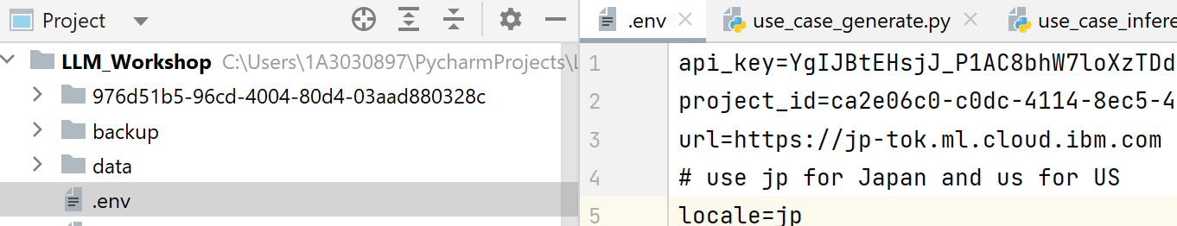

- Run the script. (Note: In VS Code, right click on the script name, then click Run Python File in Terminal / last option in the menu.) The output will be shown in Python terminal.

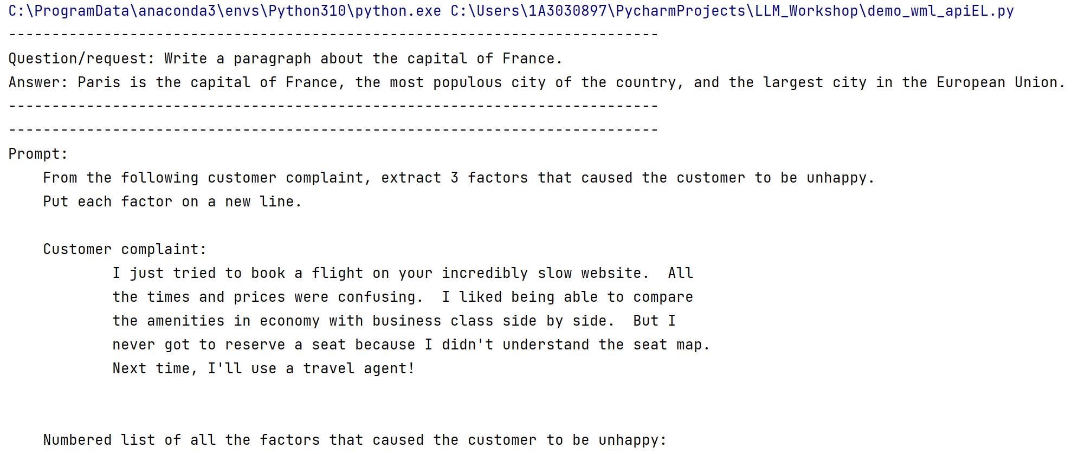

Let your instructor know if you have questions.

Next, we will invoke the LLM from a UI. We will use a popular web application development framework, Streamlit, to create a simple UI.

You can find the video of this application in the Lab_Files/Reference folder.

- To run this script, you will need to install the streamlit package in your Python environment.

pip install streamlit

Important: If you’re running on Windows, you will need to run this script in an Anaconda Python environment because it is the only supported Python environment on Windows. Both VS Code and Pycharm can be configured to use Anaconda. Please check with your instructor if you need help with setup instructions. If you’re not able to install Anaconda in your environment, please check with your instructor.

- Open the demo_watsonx_api_with_streamlit.py script. This application uses similar code to invoke the LLM as a previous example.

The application has 4 functions:
- get_credentials(): reads the api key and the project id from the .env file (will be used for authentication
- get_model(): creates an LLM model object with the specified parameters
- get_prompt(): creates a model prompt
- answer_questions (): sets the parameters and invokes the other two functions.

As you can tell by the name of the last function, this is a simple Question and Answer UI. You will notice that the prompt is more complicated than the prompt in the previous example: we provide instructions and a few examples (few-shot prompting).

Notice that we are hardcoding the instruction to answer the question. This is just an example, and you can choose to parameterize all components of the prompt.

- When you run the script, Python will open the Streamlit UI in your browser.

If you invoke Python application from a terminal, and not an IDE then use the following command: streamlit run 2_demo_watsonx_api_with_streamlit.py

Note: When testing, ask “general knowledge” questions keeping in mind that our prompt is not sophisticated and that the model was trained on generally available data.

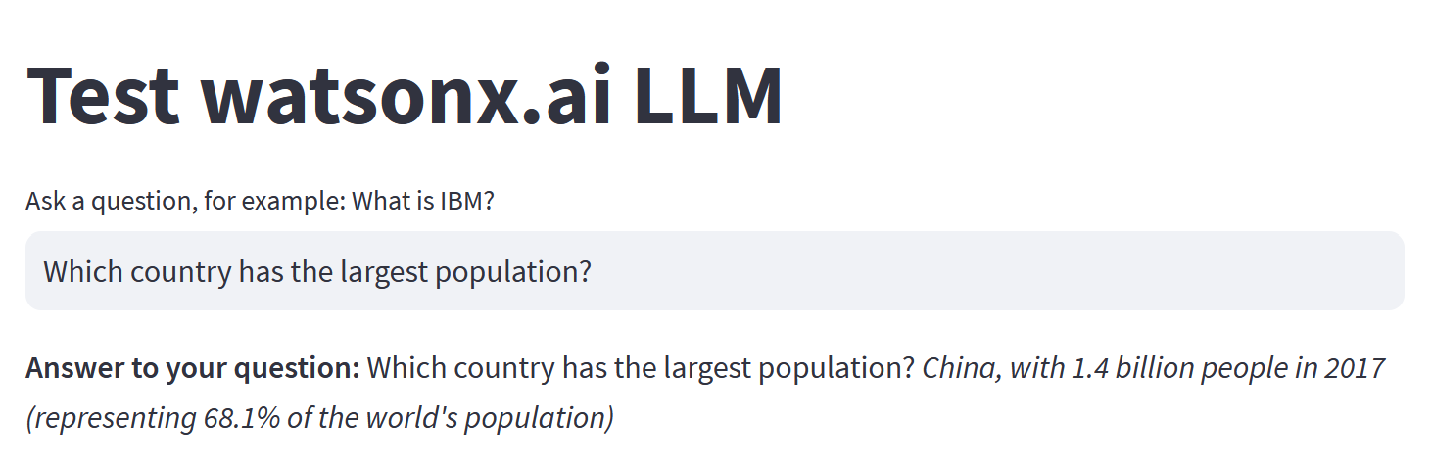

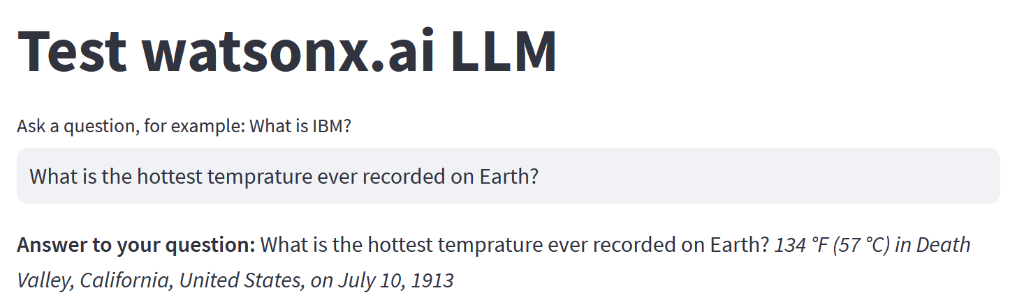

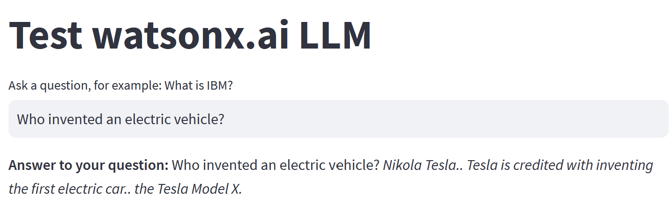

Part 3: Prompt Templates

In this section you will learn how to encapsulate your prompts in prompt templates. You may have noticed that we used the following workflow in the lab:

  - Create a prompt in the Prompt Lab.
  - After testing the prompt, copy the string containing the prompt into the client application.

For simplicity, we hardcoded the prompt into our Python script. We can improve this code by extracting prompts into their own modules or files that we can load from Python scripts, but this approach does not solve the issue of having “business logic” (prompt) in the “UI layer”. Another potential issue for this implementation approach is lack of governance for prompts.

Some developers may argue that using Git and standard DevOps workflow addresses this issue, but we have to keep in mind that application that include AI components have higher requirements for transparency and auditing compared to other components of applications.

In watsonx.ai we can use prompt templates to keep the majority of the prompt in the “business logic” layer of the application. In this lab we will explain how to create, deploy, and invoke a prompt template. Prompt template governance is covered in the Introduction to AI Governance lab.

- Open the Prompt Lab and create a new prompt.

- Switch to Freeform mode. Copy prompt text from Prompt_Template.txt file in the Lab_Files/Prompts folder.

Let’s review this prompt.

- This prompt contains system instructions for the llama3-70b-instruct prompt.
- The rest of the prompt is generic, instructing the model how to answer questions.
- Notice that we have {question} in the prompt. This is a variable that we will configure and pass in from the client application.

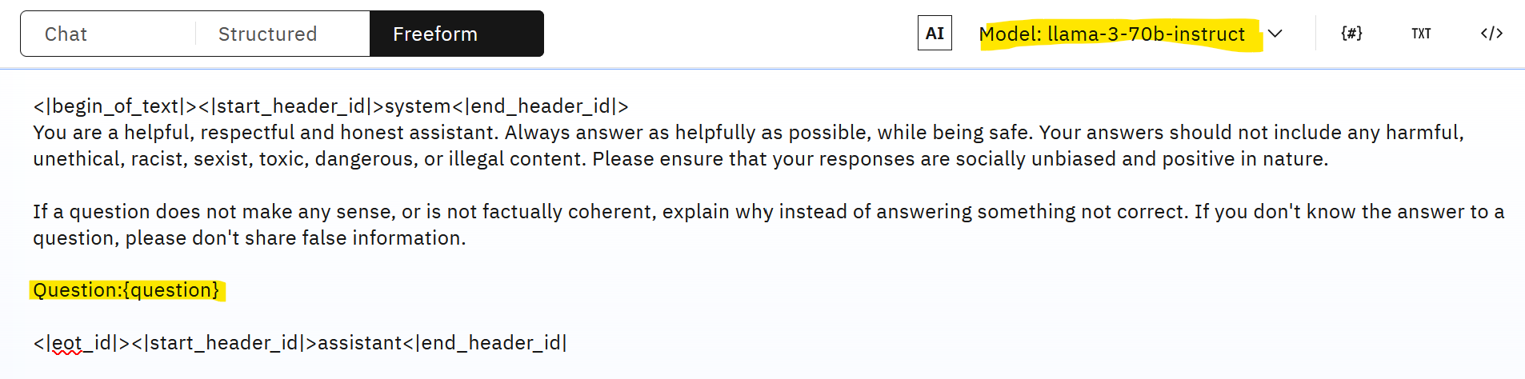

- Configure model parameters. You may choose different number of tokens for input and output and sampling if you would like to get more variation in answers.

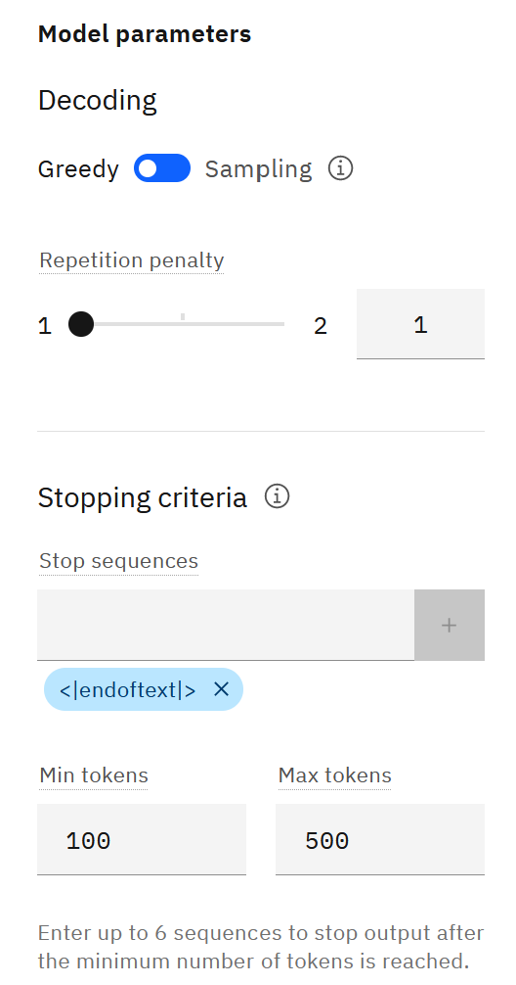

- Click on the Prompt variables icon.

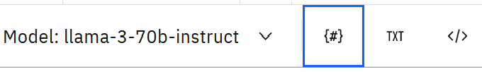

- Click New Variable and add the question variable as shown in the screenshot. Provide a default question value, for example, What is a Large Language Model?

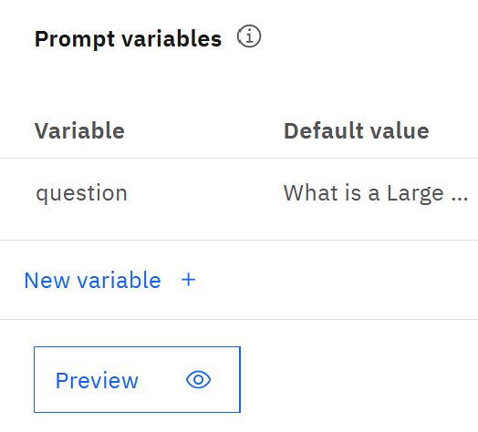

Click Preview, then Generate to verify that the parameter is replaced correctly.
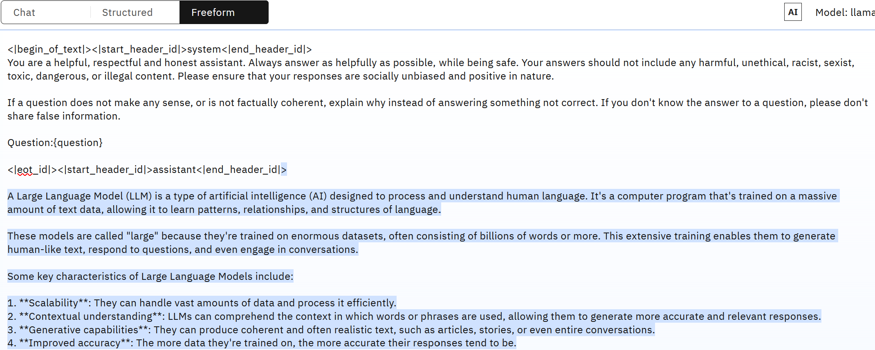

If you wish, test with other questions (modify them in the Prompt variables view).

Next, we will save and deploy the prompt.

- In the Prompt Lab UI, click on the Save icon and select Save as.



Specify the following values:

- Asset type: Prompt template:
- Name: Generic_question
- Taks: Question answering
- Description: optional

Click Save.

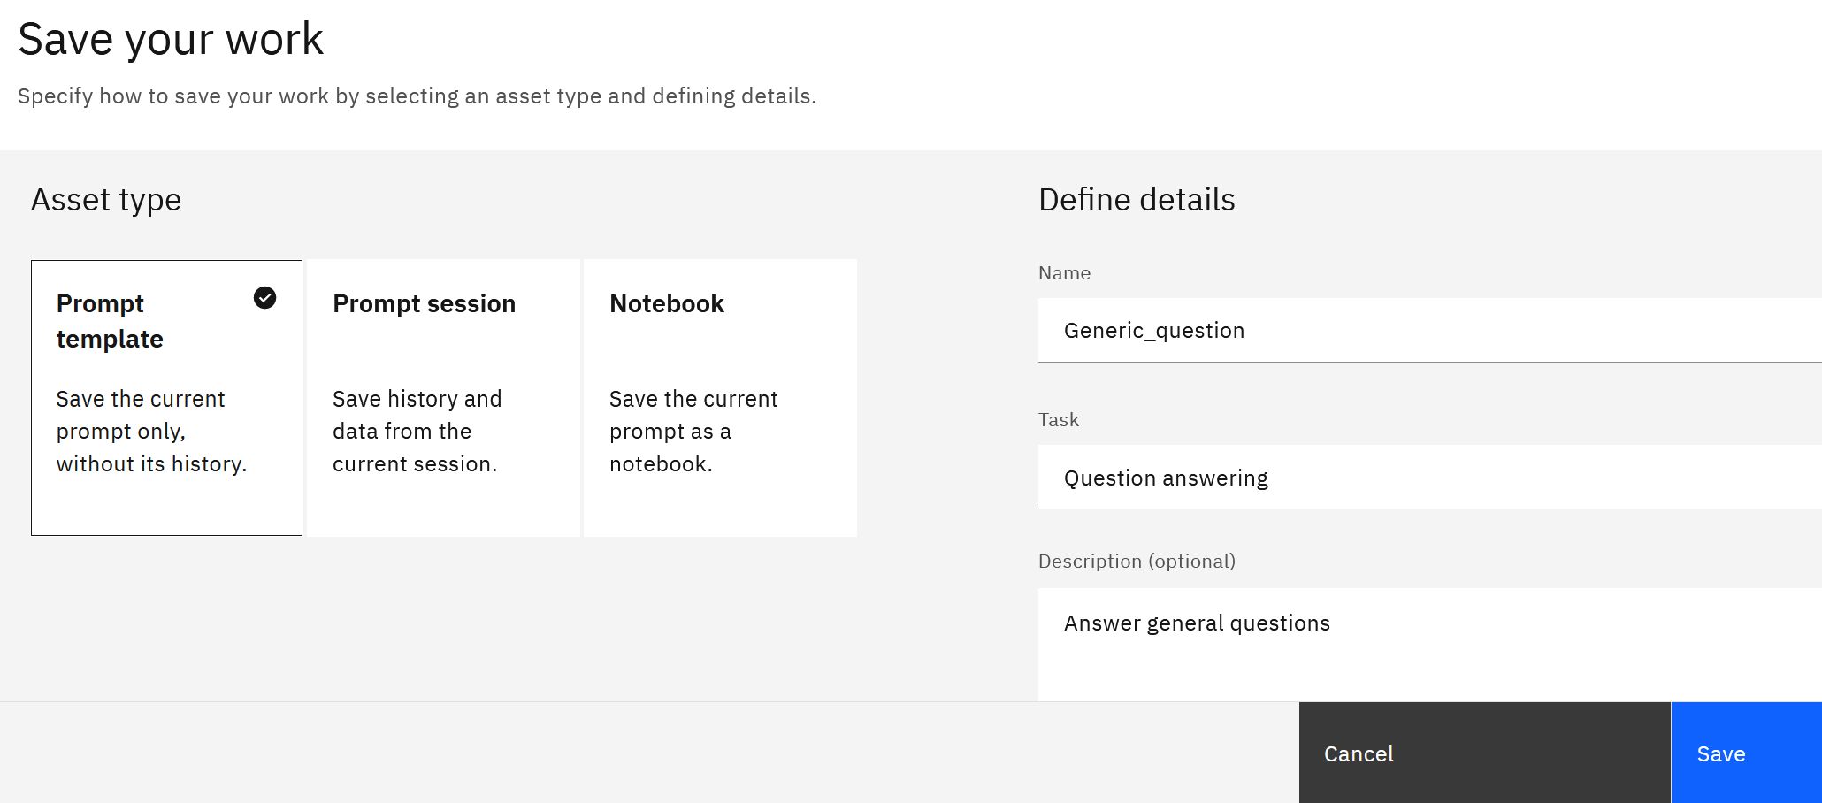

- Navigate to the saved prompt in the Assets view of the project.

From the actions menu for the prompt, select Promote to space.

Note: In watsonx.ai Deployment Spaces or simply spaces are used to separate assets from development and production. You can think of a space as a “project for assets (templates, ML models, notebooks, scripts, jobs, Python functions, etc.) that are used by production applications. Each space has its own Access Control List, providing security for production applications. In addition to that, the action to promote to space is also controlled by roles.

In this lab each student will create their own Deployment Space. In production, Deployment Spaces are created for different applications or projects.

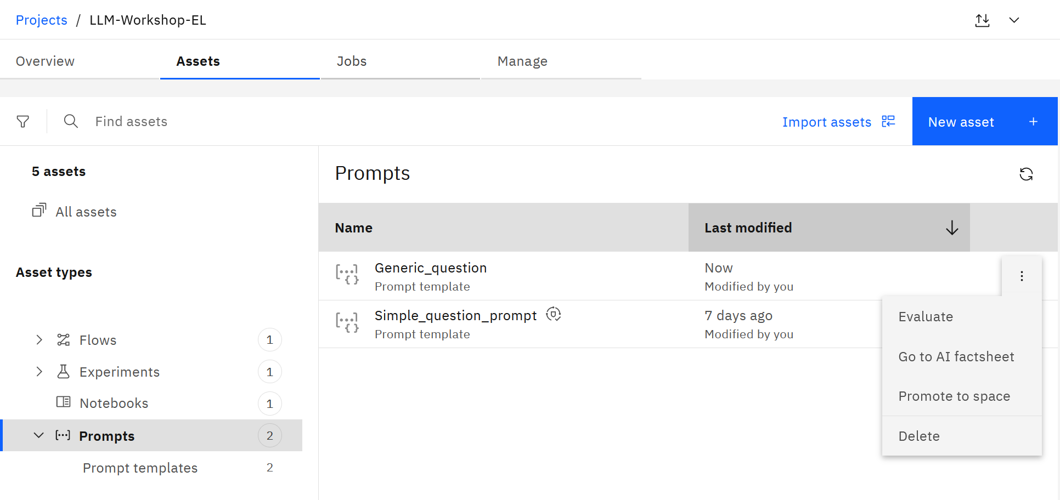

- In the Promote to space window click Create a new deployment space.

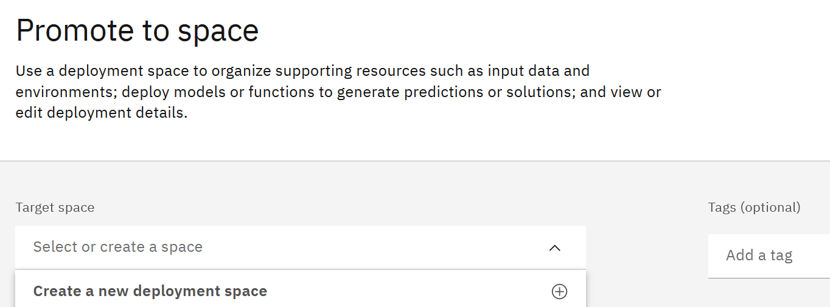

- Provide a unique name for the space and make sure to select storage service and machine learning service. Choose Testing as Deployment stage.

Note: your service names will be different.

Click Create.

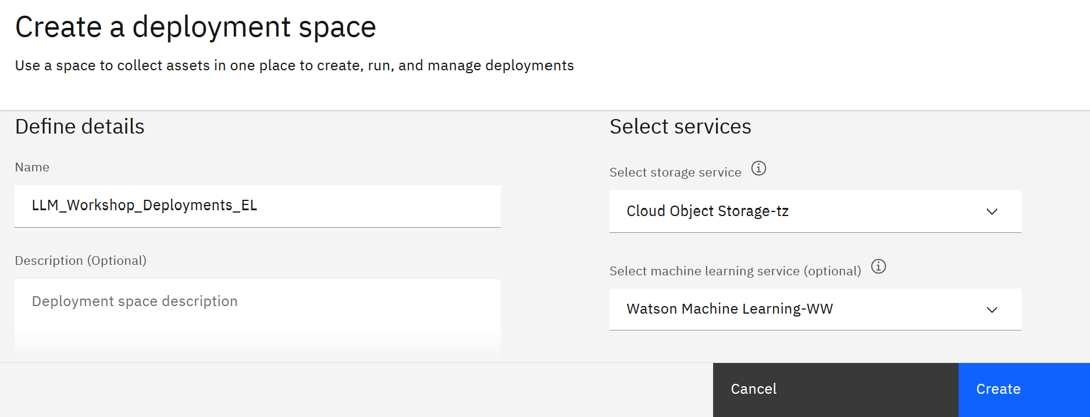

- Select the newly created space and click Promote.

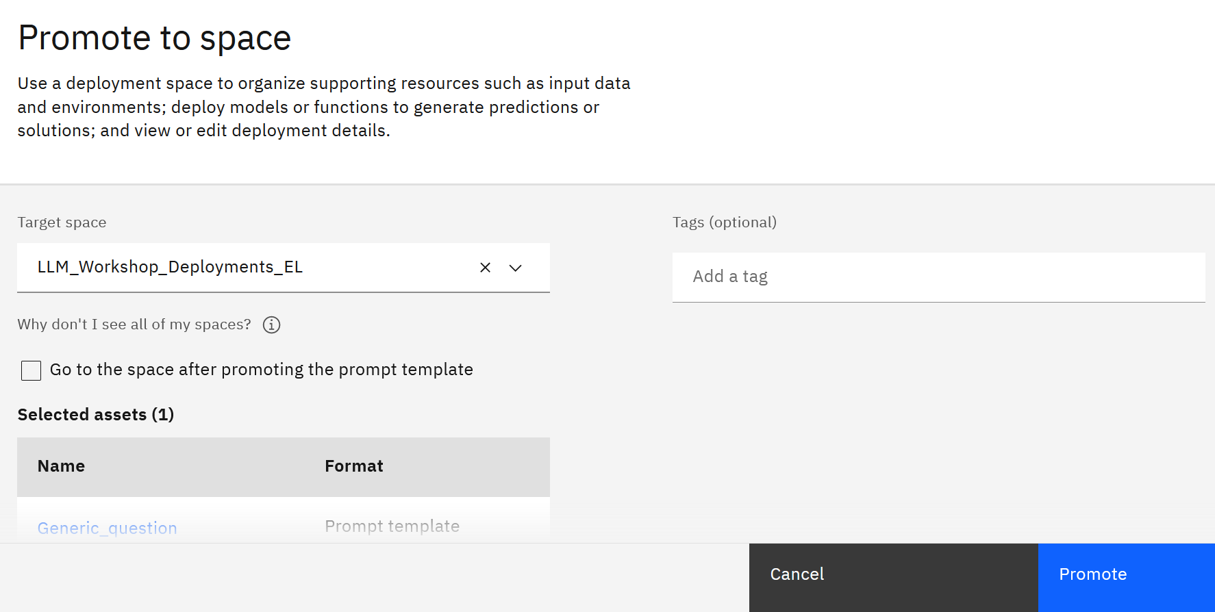

- You can navigate to the space by selecting the hyperlink in the success message or selecting Deployments from the main watsonx.ai menu.

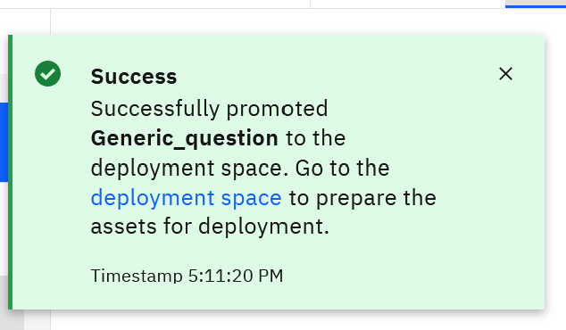

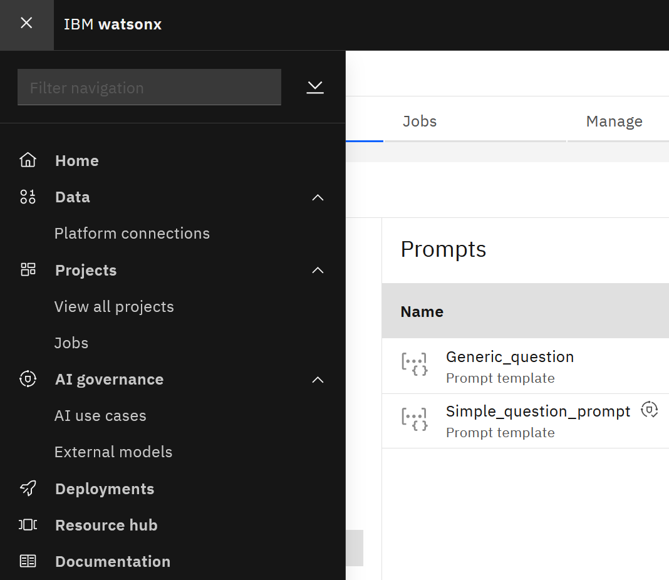

- In the Deployment space, navigate to the Assets view and click on Deploy from the actions menu of the template.

This step will create a REST endpoint for the template.

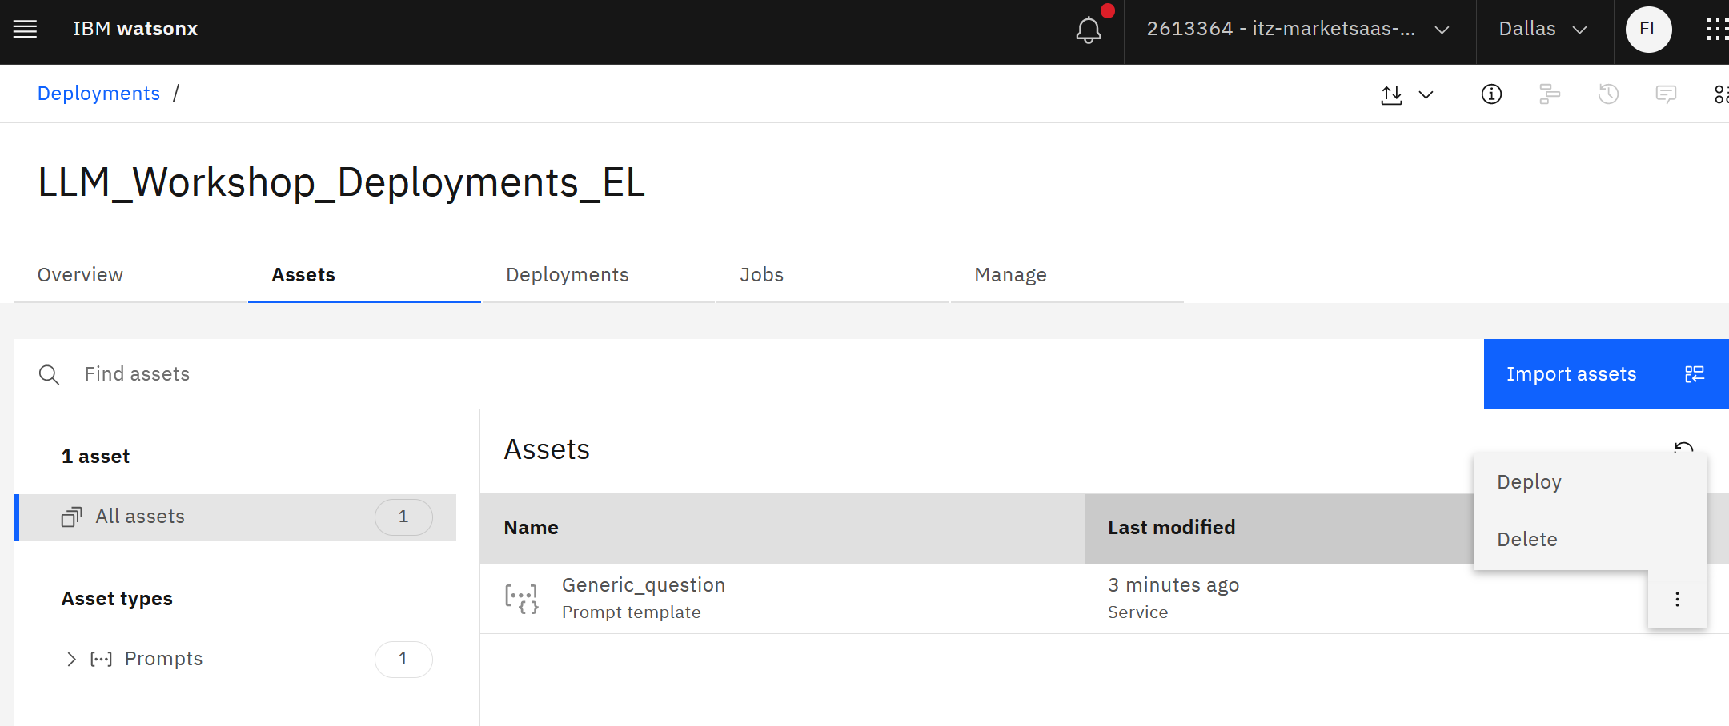

- Provide a name for the deployment, for example, Generic_question_template_deployment, and click Create.

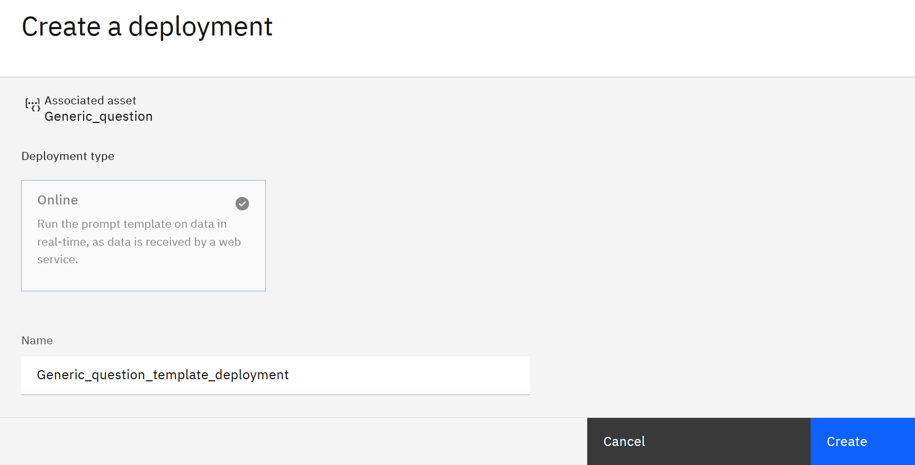

The deployed template will be shown in the Deployment view.

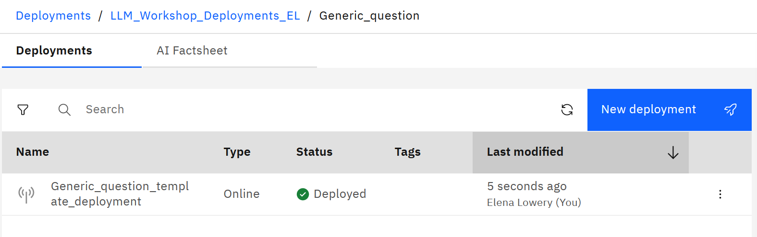
- Click on the template. Here we can find the REST endpoints, a Test interface, and a deployment id, which we will need for integration with the client application.

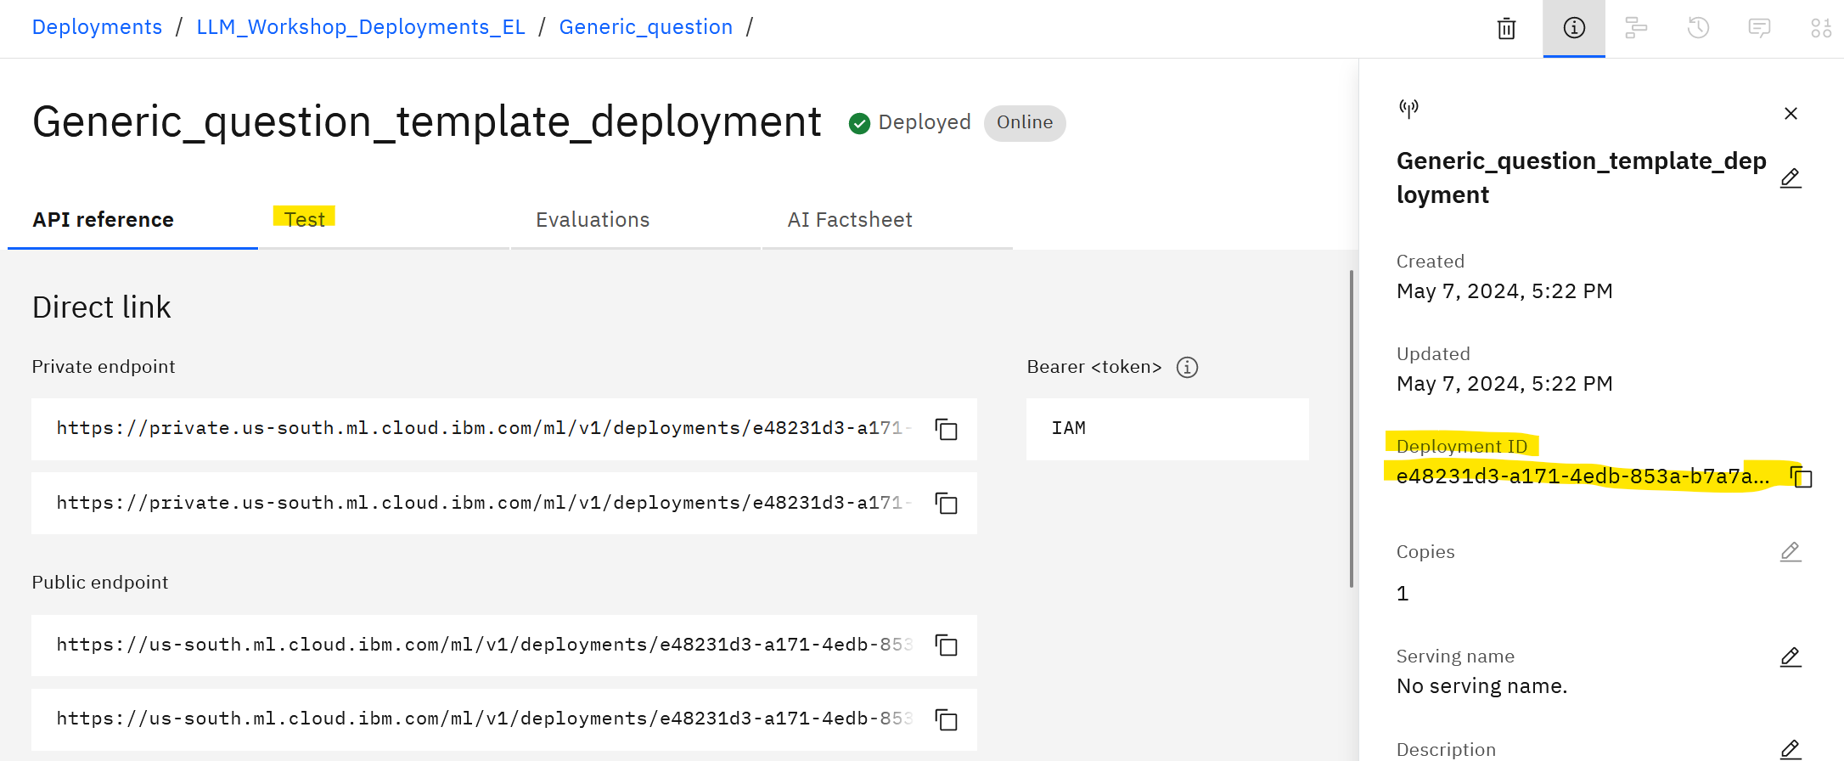

- If you wish, test the template with different questions.

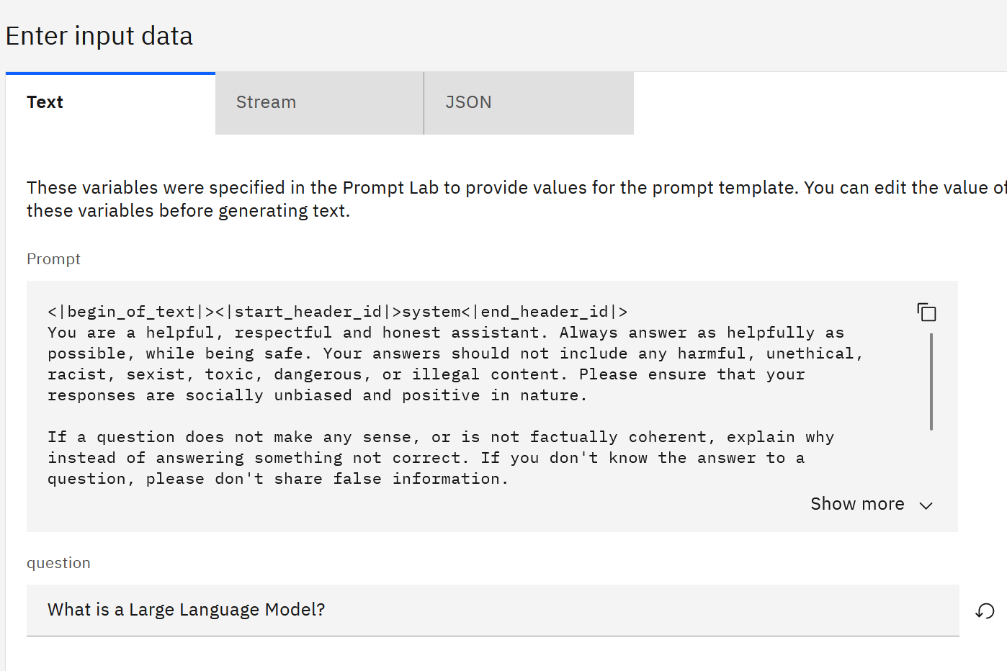

- Copy the deployment id – we will use it in the Python code to invoke the template.

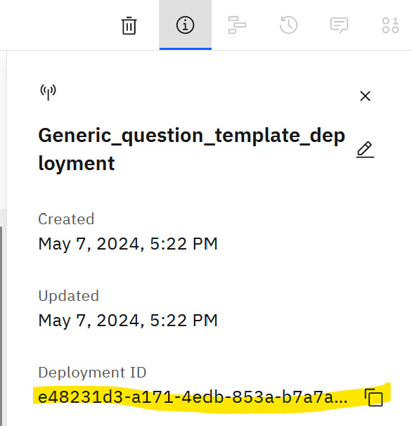

- Next, copy the space id. Navigate to the Manage tab of the Deployment Space and copy the Space GUID.

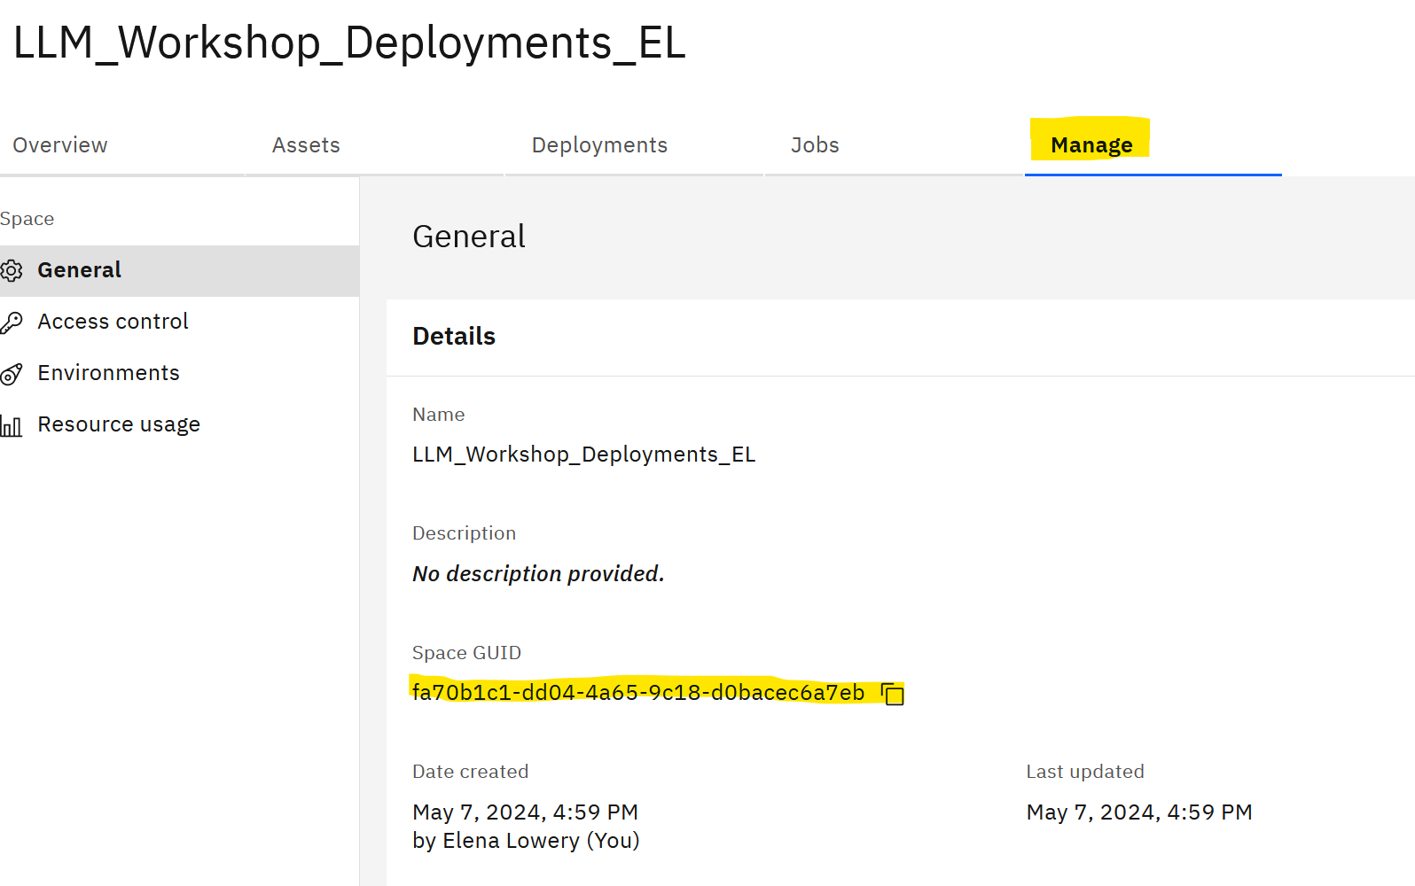

Next, we will update the test script with values specific to the deployment template.
- In your Python IDE open the 1_demo_watsonx_ai_api.py script which you used earlier in the lab.
Locate the demo_LLM_Invocation() function and uncomment the section that invokes the template. Replace space id and deployment id functions. If you wish, you can provide a different question.
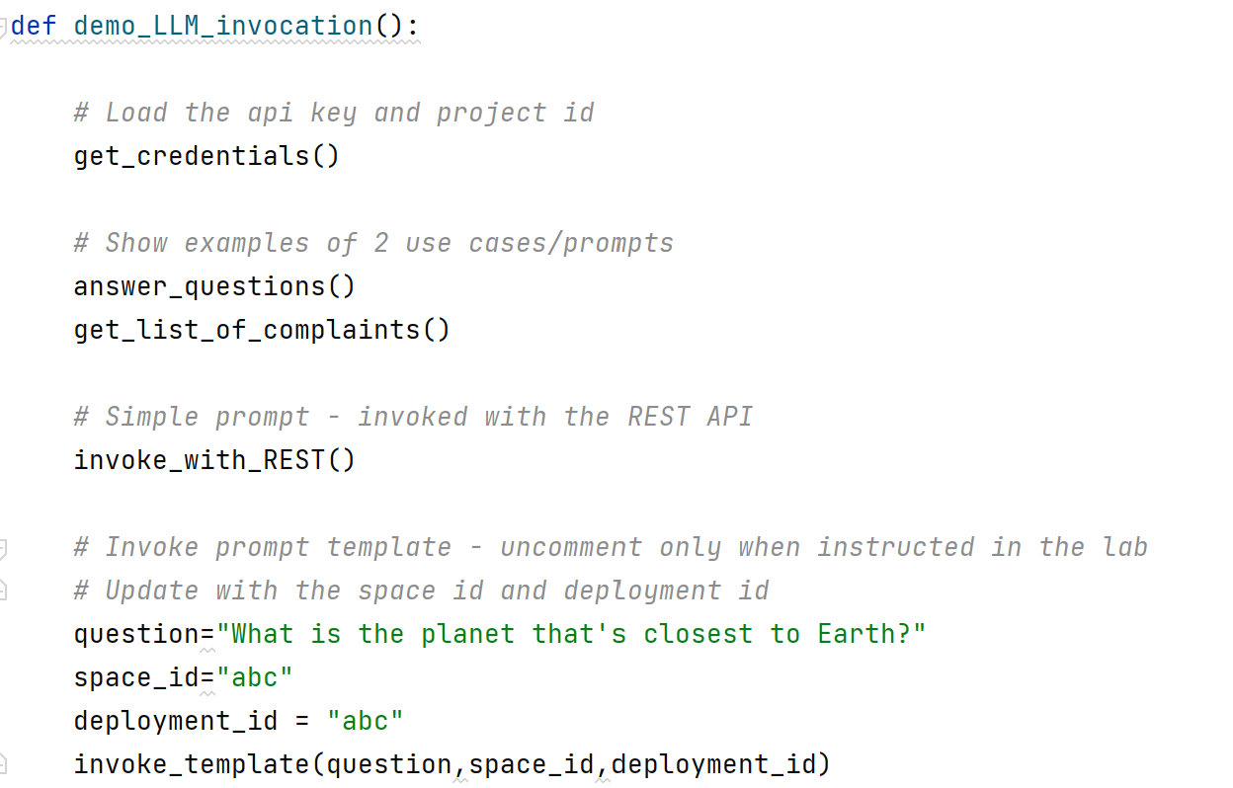

- Find and review the invoke_template() function.
Notice that our code is much “cleaner” – we pass just the parameter (question) to the prompt.
Using prompt templates provides better organization of code and it also allows us to track templates for governance (explained in the Introduction to AI Governance lab).
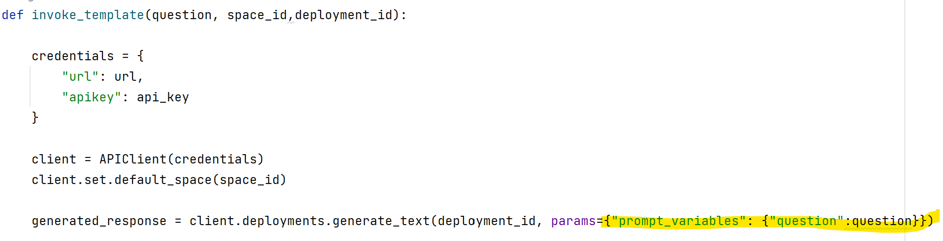
- Run the script and let the instructor know if you have questions.

Conclusion

You have finished the Introduction to Generative AI lab. In this lab, you learned:

- Key features of LLMs
- The basics of prompt engineering, including parameter tuning
- Using the Prompt Lab to create and test prompts with models available in watsonx.ai
- Testing LLM model inference
- Creating a simple UI to let users interact with LLMs.

What we did not cover in this lab:
- Using LLMs to answer questions on data specific to the enterprise
- Executing multiple instructions with LLMs
- Implementing session management in LLM applications.

If you have questions about these topics, please contact your instructor.

